Mold Surface Contamination During Polymer Processing

Zdenek Dvorak^{1,2}, Eva Hnatkova^{1,2}, Michal Sedlacik^{1,2}

¹ Department of Production Engineering, Faculty of Technology, Tomas Bata University in Zlin,

Vavreckova 275, 760 01 Zlin, Czech Republic. E-mail: zdvorak@ft.utb.cz, ehnatkova@ft.utb.cz, msedlacik@ft.utb.cz

²Centre of Polymer Systems, University Institute, Tomas Bata University in Zlin,

Trida T. Bati 5678, 760 01 Zlin, Czech Republic
The aim of this work is concerned with a problematic adhesion of polymer materials on the surface of processing tools. Such phenomenon plays especially an important role in production of rubber components which creates an additional and considerable costs associated with mold cleaning. However, the origin of contamination is still not fully known yet. From production point of view, the attention should be paid to three fundamental aspects: processed material, material of processing tool, and processing conditions. This study describes the results of mold’s surface contamination during processing a rubber compound in terms of material and surface treatment. A method of spectral analysis in terms of FTIR was used for proper examination of this problem.
Keywords: Rubber; Fouling; Contamination; Mold surface; FTIR
- Introduction

Processing of polymeric materials in general terms is accompanied by a number of various actions, which are associated with heating of the material and with its processing at recommended temperature. From processing point of view, when the polymers are heated up to the processing temperature, the material can undergo a physical change, chemical reaction or their combination. Materials are thermally stressed during processing and may be thermally decomposed. It has to be considered that processed plastics are not usually based only on pure polymer, but commonly contains additives that promote particularly its flowability, protective agents, colorants, and other raw materials that modify the physical or chemical properties such as fillers etc. [1-3]

In the case of production of rubber compounds containing a large number of component with the further vulcanization is also the complex issue [4]. Nowadays, mould fouling is a commonly seen phenomenon in the rubber industry [5]. This drawback reduces the production quality and tool maintenance increase the production cost. Generally, vulcanization of rubber can be achieve in form of extruded shape, in continuous vulcanization equipment without mold or inside the mold cavity of specified shape which is designed considering the production technology.

It is well known that contamination of processing tools may occur already during the rubber compounding. Nevertheless, this topic is not concluded in presented paper. The most serious problems associated with contamination occur in mold cavities intended for rubber vulcanization, not only in gate system, but particularly in the functional parts of the internal mold surface, especially in place of bead rings. Accumulated fouling adheres to the mold surface and causes a (building up) layer of deposit as shown in Fig. 1. As a consequence, there is a risk to produce a low quality products [6].

Contamination of mold surface negatively affects the appearance of the final products, dimensional accuracy as well as it impedes the difficult ejection of vulcanized moldings from the tool. Consequently, cleaning of the mold surface cavities possess a risk of tool damage, which is costly. Therefore, the contamination in form of mold fouling is a serious problem in the manufacturing process [7]. However, up to date the origin of surface fouling is still not well understood and its detection is an unexplored area as well.

Fig. 1 Fouling of the mold surface during vulcanization

The presented paper focuses on mold contamination during processing the rubber compounds with further rubber vulcanization due to the significant problem in company producing tires [8-9]. A successful approach to solve the contamination problem should involve the identification of the contamination during vulcanization and its source. Hence, the aim of this work was to select and determine a suitable method for evaluation of the fouling residue on the mold surface. In the experimental part, the rubber compound is molded into the mold cavity having surface from different steel inserts (plates). After certain amount of vulcanizing cycles, the inserts are removed from the mold and afterwards adhering residue are analysed by optical microspy and Fourier transform infrared spectroscopy (FTIR). Both methods belong to a group of non-destructive methods.
- Contamination of mold surface

Source of contamination is comprehensive and includes generally two possible mechanisms. In the first case, the mold fouling is caused by migration of the components through the mixture from inside to the surfaces that occurs mainly at particularly high processing temperature. Diffused components then adhere to the mold cavity, where degradation occurs and foulings are gradually accumulating. The same can happen by releasing mold agents which during processing become a part of the mixture. These are thermally decomposed and can cause the contamination on the surface of the mold in time as well. In the second case, elastomers are subjected to the reversion or oxidation. The consequence is in formation of reversion sticky residue resulting in creation of a tough film. Then, this film adheres to the mold surface [10].

Fouling of a mold caused by vulcanization of a rubber compound in the mold is distinguished by its level of contamination (intensity) as a simple matting of functional mold surface, as a deposition of contaminant material across the whole mold surface, or by flaky deposits resulting at first in visual defects and later in dimensional changes of vulcanized rubber [11].

Factors affecting mold contamination:

rubber compound (rubber, system of fillers, processing aids, protection additives, curing system etc.).

design of the mold (especially shaped cavities, runner system, and inlet gate), material of the mold, its manufacturing process, post-heated treatments which affect the hardness and roughness of inner surface and other surface treatments, and the degree of metal surface oxidation or its storage.

processing technology (process conditions and used separators).
- Experimental (material and methods)

In this study, a rubber compound for production of bead components in the manufacturing of tires has been selected due to its enhanced surface contamination. Tab. 1 demonstrates general components in rubber mixture recipe which is curently used in one unnamed tire company.

Tab. 1 Rubber compound’s composition
Component | wt. (%)
Natural rubber | 9.36
Synthetic rubber | 37.4
Regenerate | 2.81
Carbon black n0550 | 17.8
Carbon black n0339 | 15.5
Processing aids | 0.09
Plasticizer - wax | 0.47
Plasticizer - oil | 0.87
Activator - ZnO | 1.40
Activator - Stearin | 0.70
Plasticizer | 1.41
Resin | 2.34
Antidegradant | 1.87
Accelerator | 1.36
Sulphur | 1.83
Retarder | 0.14
Waste from extruding | 4.68

A special mold was designed for investigation of how the tool material will influence the fouling of the mold surface and to ensure the same processing condition during vulcanization. Fig. 2a schematically demonstrates the pressing vulcanization mold. As can be seen in Fig. 2b, the bottom of the mold is constructed from 9 insert plates. Each insert (plate) which is shown in Fig. 2c is made from different steel commonly used in mold manufacturing for tire industry. Dimensions of inserts (70 x 21 x 9 mm) were designed to make the subsequent spectral analysis possible.

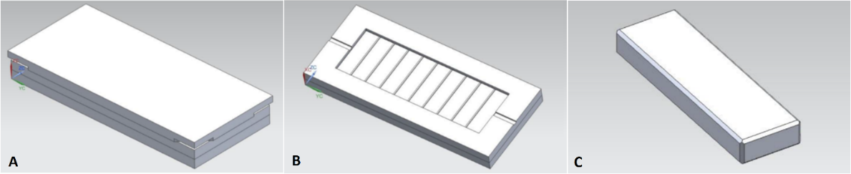
Fig. 2 Vulcanization mold (a), bottom part of the mold with particular inserts (b), mold inserts from different steel (c)

To evaluate the contamination during vulcanization, the nine type of construction and tool steels (1.0570, 1.2311, 1.2085, 1.2436, 1.2767, 1.2162, 1.2363, 1.2842, 1.2312 and 1.2379) has been selected. All of them are commonly used for production of bead ring and sidewalls tools in the tire manufacturing. Steel plates were prepared by precision machining, milling and grinding. Then, the plate roughness (R_{a}) was measured by mechanical instrument Mitutoyo SJ -301 and obtained average values of R_{a} varied between 0.23 and 0.28 μm.

After mold surface cleaning, the prepared steel inserts were placed in to the mold and further compression molding was conducted by pressing of rubber compounds using a laboratory vulcanizing press. Vulcanization was carried out according to processing parameters depicted in Tab. 2. In order to study the quantity and composition of mold fouling, a various cycles were performed (10, 25, 50, and 100 cycles).

Tab. 2 Processing parameters
Vulcanization time (min) | 4.5
Vulcanization temperature (°C) | 170
Processing pressure (MPa) | 13

Then, the mold cavity was disassembled and the vulcanized residue at different steel plates after various cycles were examined by optical microscopy (Leica DVM2500 Digital Camera, Germany) and spectral analysis. Fourier transform infrared spectroscopy (FTIR) is a well-established technique to characterize chemical composition and give an insight into the microscopic structure of constituents in a polymer composite. The purpose of the FTIR testing was to identify the residue and its source. An FTIR spectroscope Nicolet iN 10 (Thermo Scientific, USA) recording the infrared spectra in the range 680 – 4000 cm ^{–1} at 64 scans per spectrum with 2 cm ^{–1} resolution using attenuated total reflectance (ATR) technique with Germanium crystal was used for evaluation of surface contamination.
- Results and disscussions

Fig. 3 and Fig. 4 demonstrate the optical images of mold cavity inserts fouling after repeated compression molding of carbon blak-containing rubber compound using two different steel plates. However, using a different types of steel for insert plates, a small mold fouling appeared in all cases after 10 – 25 molding cycles, while a persistent deposit was found after 50 – 75 cycles. The same results have been found in the reference [12] investigating the mold fouling of compound based on EPDM, i.e. firstly adher the small products, which are subsequently rapidly accumulated.
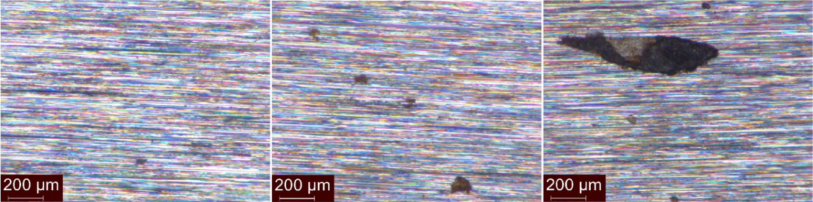
Fig. 3 Optical micrograph of steel 1.0570 plate after a) 10 cycles, b) 25 cycles, c) 100 cycles
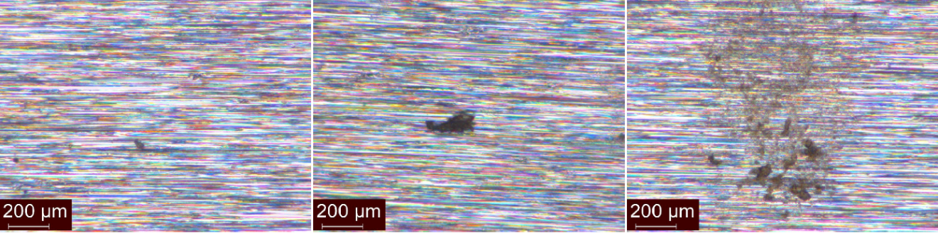
Fig. 4 Optical micrograph of steel 1.2085 after a) 10 cycles, b) 25 cycles, c) 50 cycles

The FTIR analysis was firstly carried out to reveal the contaminated residues on inserts surface, then for the analysis of selected components containing rubber mixture, and finaly for comparison of rubber compound spectra before and after vulcanization. Fig. 5 and Fig. 6 demonstrate the spectra of contaminated residues obtained after 10 and 50 molding cycles on the surface of two different steel inserts. As can be seen, the progress of chemical composition in time differs, while the influence of the tool materials demonstrates almost no dependence.

The analysed FTIR spektra are almost the same for a specific number of cycles irrespectively the steel materiál used for the insert plates. This means, that there is no relation between steel material and composition of residue. All residues are distinguished by a broad infrared band positioned in a range from 1800 to 1300 cm⁻¹. This band can be attrributed to the phenol formaldehyde resins and generally contains structures containing carboxyls, carbonyls, and –CH bonds. Other bands, around 1000 cm⁻¹ might come from siloxane structures after thermal degradation with respect to the starting rubber mixture composition.

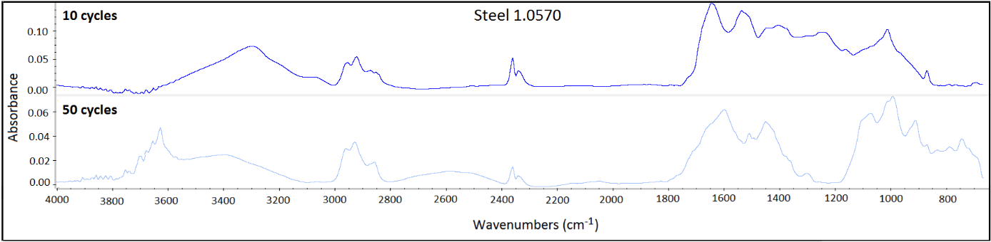
Fig. 5 FTIR spectra of rubber residue (steel 1.0570)

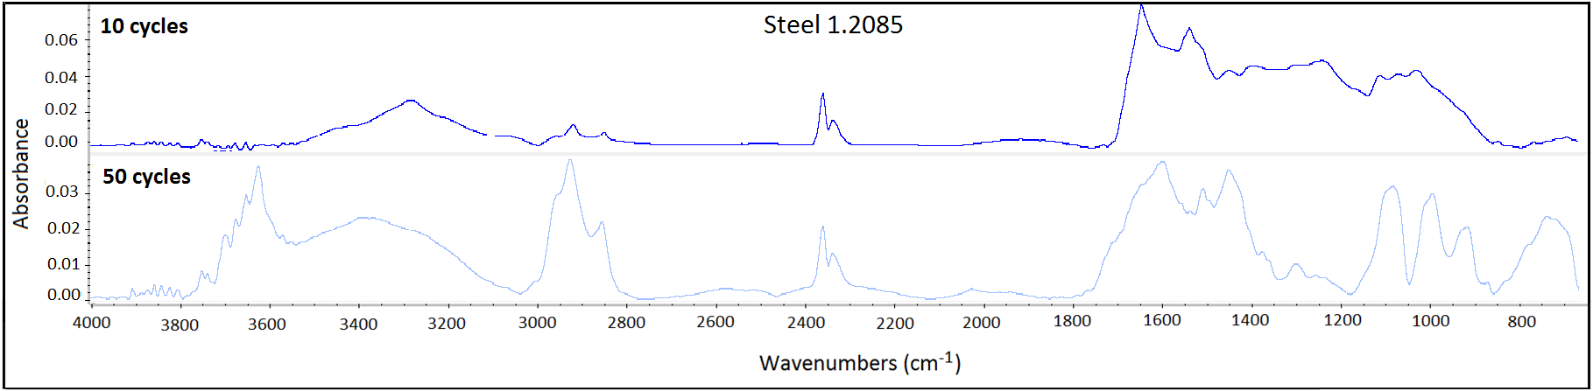
Fig. 6 FTIR spectra of rubber residue (steel 1.2085)

Fig. 7 illustrates the FTIR spectra of selected rubber mixture components. As can be compared with Fig. 5 and Fig. 6, the FTIR analysis of residues did not confirme the contamination of the mold is carried out only by one component contained in rubber mixture. Hence, it was impossible to identify the source of contamination from obtained spectra, and therefore it was further decided to compare the FTIR spectra of rubber mixture (compound) with vulcanized rubber as shown in Fig. 8. Evidently, both FTIR spectra are very similar, however, one can deduce some changes occured in the system after its vulcanization due to the formation of new bondings and consuming of some reagents, which are moreover in minor portion within the system, during the vulcanization process. In other words, some peaks presented in the FTIR spectrum of rubber compound are slightly moved to different wavenumbers while some are even disappeared due to the consumption of starting reagent. The most important wavenumber values attributed to band vibrations are for clearity and interpretation purpose shown in Tab. 3.

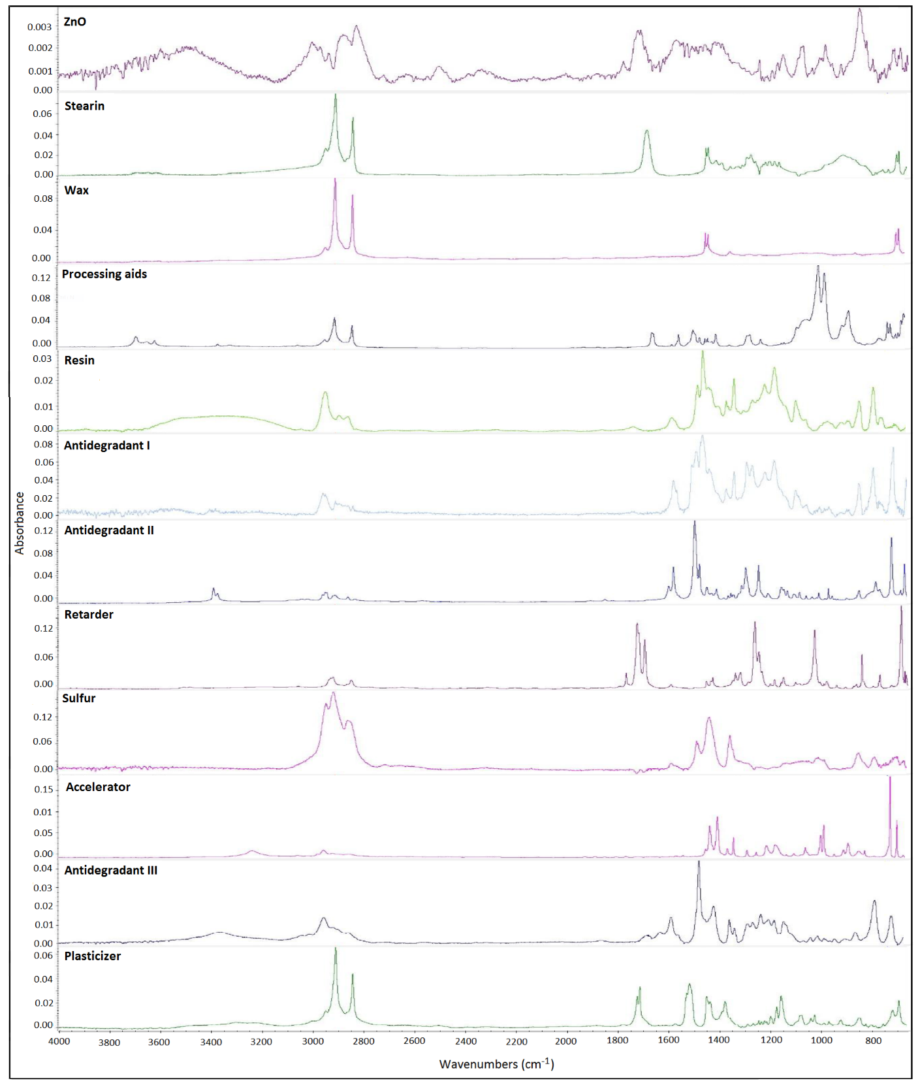
Fig. 7 FTIR spectra of selected components

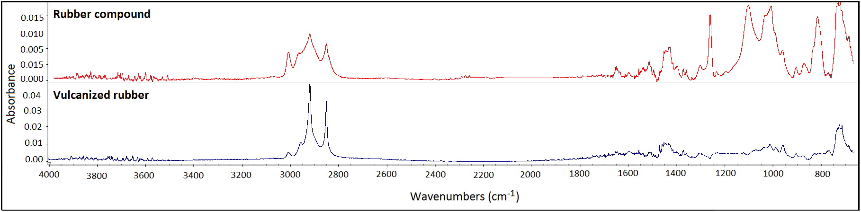
Fig. 8 FTIR spectra of rubber compound and vulcanized rubber

Tab. 3 Interpretation of FTIR spectra for rubber compound
Peak position (cm^{–1}) | Band vibration
729 | repeating more than 4 –CH₂–
833 | sulphur
990 | –C=C–
1080 | –OH
1245 | carboxyl group
1375 | cis-1,4-polyisoprene
1455 | cis-1,4-polyisoprene
1538 | Zinc stearate
1597 | –C=C– in arom. or aliph. chain
1640 | –COOH
2848 | cis-1,4-polyisoprene
2916 | –CH3 symmetric
2955 | –CH2– asymmetric
1375 | cis-1,4-polyisoprene
1455 | cis-1,4-polyisoprene
3033 | –CH3 asymmetric

Since, the residue at contaminated steel plates demonstrated the same FTIR spectra differing only in their intensity, it can be concluded that selected steel material of the tool did not play any important role in the contamination of mold surface. From obtained results it is more probable that the contamination depends on the surface quality, because the steel surfaces with less roughness were not so dramatically contamined. This theory can be explained due to better adhesion condition of raw processing materials as wax, oil, lubricants, mold-release agent, cleaning solvents and other processing aids which better adhere to the mold surface and with higher number of cycles degradated. This can have a negative impact on the mold contamination and, in addition, these chemical reactions hinder subsequent analysis. For extension study on this topic, it is necessary to increase the statistical measurement of residues, especially in the early stage of vulcanization pressing.

- Conclusion

Based on the obtained results, the FTIR analysis of residues does not confirm that the contamination of the mold is carried out only by one component presented in rubber mixture. In addition, there is no relation between selected tool steel material and composition of residue. During processing a tool may be expose to many contaminants during manufacturing. The contamination depends more on the surface quality, because the steel surfaces with lower roughness were less contamined. The most probable cause of surface contamination is due to mechanical adhesion, especially components from rubber composition with low melting point are thermally degraded. Then the adhesion consists of the chemical bonds formed between the processing aids and the mold material (steel). Rubber adhesion to the form and amount of rubber adhering to the surface of the mold is increased depending on the surface roughness of the mold. Due to the large experiment range and time consuming experiments it was not fully detected the reason of the surface contamination, but the results of performed experiments point out the direction of the next step. For the further research it is necesary to increase the frequency of statistical measurement, especially at the early stage of pressing.

Acknowledgment

This work was supported by the Ministry of Education, Youth, and Sports of the Czech Republic - Program NPU I (LO1504). This study was also supported by the internal grant of TBU in Zlin IGA/FT/2016/002 funded from the resources of the specific university research. The authors would like also to thank Barbora Hanulikova for her help with FTIR analysis.

References
[1] PREKOP, Š. (1998). Gumárska technológia I. Žilina: Žilinská univerzita.
[2] ŠPAČEK, J. (1987). Technologie gumárenská a plastikářská. Brno: VUT.
[3] DUCHÁČEK, V., HRDLIČKA Z. (2009). Gumárenské suroviny a jejich zpracování, Praha: VŠCHT v Praze.
[4] FORREST, M. J. (2001). Rubber Analysis: Polymers, Compounds and Products, Vol. 139, iSmithers Rapra
Publishing.
[5] HORNSBY, P. R., SINGH, I., DALEY, J. R., FIRTH, J. (2006). Mould fouling of elastomers during injection
moulding. Plastics, rubber and composites, vol. 35(8), pp. 331-339.
[6] HAVLÍČKOVÁ, K. (2014). Methods of Mold Cleaning from Vulcanized Residues. Master thesis, Zlín: UTB in
Zlín.
[7] DAVIS, G. D. (1993). Contamination of surfaces: origin, detection and effect on adhesion. Surface and interface
analysis, 20(5), pp. 368-372.
[8] HÁBA, J. (2015). Contamination of tool steels during rubber vulcanization. Master thesis, University of Tomas
Bata in Zlin.
[9] ČERVINKA, M. (2015). Contamination and surface protection of molds made of aluminum alloys. Master thesis,
Zlín: UTB in Zlín.
[10] DVOŘÁK, Z. (2011). Zpracovatelské procesy gumárenské: pro konstrukční směry. Zlín: UTB ve Zlíně.
[11] INSTITUT GUMÁRENSKÉ TECHNOLOGIE A TESTOVÁNÍ ZLÍN (1996). Problematika špinění forem:
Studie o příčinách vzniku a možnostech jejího snížení. Zlin.
[12] BUKHINA, M. F., MOROZOV, Y. L., Van de VEN, P. M., NOORDEMEER, J. W. M. (2003). Mould fouling of

