A Novel Ecological Extraction Strategy for Recovering Phenolics from Solanum lycopersicum Residue by Combined Steam Explosion and Enzymatic Hydrolysis
Jakub Klabanª, Fernando Bonfiglio^{b}, Tomas Sopikª, Monika Strasakovaª, Klaudia Chmelovaª, Vladimir Sedlarik^{a, *}
ªCentre of Polymer Systems, Tomas Bata University, trida Tomase Bati 5678, 760 01 Zlin, Czech Republic
^{b}Latitud, Av. Italia 6201, 11500 Montevideo, Departamento de Montevideo, Uruguay
*Corresponding author.
E-mail address: sedlarik@utb.cz (V. Sedlarik).
ABSTRACT
This study describes the controlled release of phenolic compounds from residue gleaned from tomato (Solanum lycopersicum) stems. These were pretreated by steam explosion under various conditions, including pressure, residence time and particle size, before undergoing solid–liquid separation. The solid fraction was subjected to Soxhlet extraction and two methods of enzymatic hydrolysis A and B. Such enzymatic treatment B combined with steam explosion of 3.07 severity on particle size under 250 µm increased the amount of phenolic content obtained from 2.0 to 21.0 mg GAE/g, while flavonoid content rose from 2.6 to 8.0 mg RE/g. The liquid fraction yielded up to 18 mg GAE/g of phenolics and 4 mg RE/g of flavonoids. Spectroscopic determination and morphological analysis confirmed that heightened pressures and reduced particle sizes promoted matrix disruption and compound release. These findings show that steam explosion-assisted extraction constitutes a promising and sustainable strategy for the valorization of agricultural tomato residues.
Keywords
Second-generation lignocellulosic biomass; steam explosion; valorization of tomato by-products; chromatography; phenolics
- Introduction
Transitioning towards a circular bioeconomy demands innovative strategies, involving the valorization of enormous volumes of agricultural residues exceeding 3803 million tons annually (Rao et al., 2024). A major farming segment is tomato production (Solanum lycopersicum), estimated at the amount of 45.8 million tons in 2024 (Dillon, 2024), thereby generating significant quantities of lignocellulosic by-products, including stems and leaves (Almeida et al., 2024). Tomato stem residues (TSRs) represent 2% to 5% of the total yield of the crop in dry weight (Dw), with up to 33 kg of biomass comprising fresh stems and leaves generated per 100 kg of harvested tomatoes (Bolaño et al., 2024; Uwihanganye and Snoo, 2021). Waste TSRs are often dealt with via open burning or deposited in landfills, contributing to greenhouse gas emissions and soil degradation, respectively (Chang and Joye, 2024). TSRs contain bioactive compounds, e.g. phenolics and flavonoids, known for their antioxidant, anti-inflammatory, and antimicrobial properties (Ouatmani et al., 2023), which have the potential for use in the food, pharmaceutical, cosmetic and packaging sectors (Sun and Shahrajabian, 2023; Wu et al., 2022).
Although tomato leaves typically contain higher concentrations of phenol, processing substantive volumes of TSRs is considered most applicable for industrial-scale valorization (Silva-Beltrán et al., 2015). Recent studies have reported that the method gives rise to products suitable for bio-based packaging or as biofuels and functional food ingredients. TSR-based paperboard and corrugated cardboard was described by Gregor-Svetec et al. (2024) as possessing enhanced mechanical properties suitable for various packaging applications. Chowdhury et al. (2025) demonstrated the capacity of TSRs for conversion into biofuels via pyrolysis and fermentation. Enzymatic treatment was shown to improve the mechanical and optical properties of paper-based materials (Sežun et al., 2023). Life cycle assessments confirmed the environmental benefits of integrating TSRs in sustainable materials (Tsouti et al., 2023). Research was also conducted on food ingredients derived from tomato by-products, which had potential health benefits pertaining to their inherent antioxidant and antimicrobial compounds (Szabo et al., 2019).
The act of extracting phenolic compounds from tomato-based residues has typically centred around pomace and peel via techniques such as ultrasound-assisted and microwave-assisted extraction (UAE and MAE, respectively), which improve yields and reduce solvent usage compared to conventional methods (Panagiotopoulou et al., 2022). Of particular interest is a procedure referred to as steam explosion (SE), a highly efficient and environmentally-friendly form of thermal pretreatment with low energy demands. It involves the brief exposure of biomass to high-pressure steam and subsequent rapid decompression, thereby disrupting the cell wall matrix and releasing bound compounds as liquid and solid fractions (Mosier et al., 2005; Silveira et al., 2015). Using steam explosion in a biorefinery concept where multiple products can be obtained contributes to the overall economic viability of the process (Baral and Shah, 2017; Elwakeel et al., 2025; Mesfun et al., 2019). Furthermore, in many lignocellulosic biorefinery configurations, process heat and power can be partially supplied through the combustion or valorization of lignin-rich residues, an approach analogous to the energy integration strategies employed in kraft pulp mills. SE has also been successfully applied to other agricultural residues, including barley bran and pomegranate peel, so as to enhance phenolic extraction and antioxidant activity (Chang and Joye, 2024), yet little research is reported on its adoption with regard to TSRs.
Notably, combining SE with enzymatic hydrolysis presents a promising but overlooked strategy for TSR valorization (Wan et al., 2022b), with the potential to maximize the extraction of phenolics and flavonoids. Findings show that carrying out enzymatic hydrolysis with pancreatin in combination with bile at neutral pH increases the amount of recoverable flavonoids, while acidic conditions heighten total phenolic recovery (Pinto et al., 2023). Bovine serum albumin (BSA), often utilized in extraction protocols, is capable of binding and stabilizing liberated phenolics, aiding their solubility and measurement (Laranjeira et al., 2022).
While it is standard practice to obtain data via UV-Vis methods on initial total phenolic content (TPC), flavonoids, and antioxidant activity, it is necessary to perform deeper compositional analysis as well. This involves high-performance liquid chromatography (HPLC), whereby quantification of targeted phenolic acids occurs, e.g., chlorogenic, ferulic, sinapic, syringic, p-Coumaric, and vanillic acids, as well as catechins and 3,4-dihydroxybenzoic acid. It is worthy of mention that limited comparative evidence exists on the aforementioned combined SE-enzymatic approach in contrast with conventional extraction techniques (e.g., Soxhlet), in terms of extraction efficiency, phenolic composition, antioxidant activity, and morphological changes observable via scanning electron microscopy (SEM).
Despite growing interest in the valorization of tomato by-products, the application of SE to TSR, especially in combination with enzymatic hydrolysis, remains under-explored. Furthermore, there is limited comparative evidence on its effectiveness compared to conventional extraction methods such as Soxhlet extraction, particularly in terms of phenolic yield, composition, antioxidant activity, and structural changes. This study addresses this gap by systematically evaluating the combined SE-enzymatic approach and directly comparing it with conventional extraction to assess its potential for sustainable TSR valorization.
- Materials and methods
  - Reagents
Folin–Ciocalteu phenol reagent, gallic acid monohydrate, gallic acid (certified reference material), L-ascorbic acid, 2,2-Diphenyl-1-picrylhydrazyl (DPPH), sodium taurocholate, lecithin, pepsin, sodium chloride (NaCl), porcine bile extract, palmitic acid, BSA, pancreatin, tris-maleate buffer, potassium chloride (KCl), sodium carbonate (Na₂CO₃), calcium chloride (CaCl₂₎, hydrochloric acid, bovine bile salt, methanol, acetone, acetonitrile, sulphuric acid (H₂SO₄), sodium chlorite (NaClO₂), sodium acetate (CH₃COONa), sodium hydroxide (NaOH), acetic acid (CH₃COOH), sodium nitrate (NaNO₃) and aluminium chloride (AlCl₃). All the chemicals were commercially available, of pure/analytical grade, and employed without further purification. Every reagent applied in this study was sourced from a chemical distributor, e.g., Penta Chemicals, Sigma, Biosolve-Chemicals, and Honeywell.
  - Lignocellulosic biomass
This study utilized residues from agricultural tomato production, primarily leaves and straws, obtained from the Bezdínek farm in Dolní Lutyně (Czech Republic; coordinates: 49.914262719402956, 18.44543984209592). The resultant biomass was crushed into pieces by a knife mill (EVERPLAST MACHINERY CO. LTD, model no. A-150 CE), then divided into separate fractions by sieves (Analysensieb) graded as 18, 35, and 60 according to ASTM E11. The humidity of these fractions equalled 8.65%, and each was individually stored in a plastic container at room temperature while awaiting further processing. TSRs were selected for the experiment since the Czech Republic produces a high amount of tomatoes (12869 t in 2021, 13461 t in 2022, and 20302 t in 2023; Czech Statistical Office, 2023), with such output rising every year.
  - Lignocellulosic compound determination of TSR
The primary composition compounds in the TSRs, e.g., cellulose, hemicellulose, and lignin, were determined by the Klason lignin method, wherein the separation of acid-insoluble and acid-soluble lignin fractions transpired by acid hydrolysis. Values for cellulose and hemicellulose contents were estimated based on the compositional analysis of the hydrolyzed sugars. The given methodologies were conducted in accordance with previously established protocols (Chen, 2015; Sluiter et al., 2012), ensuring reproducibility and accuracy in biomass characterization. All the experiments were performed in triplicate to minimize variability and improve the reliability of the data. The findings provided insight into the structural composition of the TSRs and served as a basis for evaluating their suitability for further processing or valorization.
  - Steam explosion pretreatment
The SE pretreatment was performed on a custom-made device, a BH 200 Batch Hydrolyzer (3V Tech s.r.o., Czech Republic), in accordance with a method described by Gong et al. (2021). The SE device was equipped with an electric water boiler to generate saturated steam, a 5-litre batch reactor, and a cyclone with a 3-litre receiver for collecting the consequent product. A simplified schematic diagram of the SE process is given in Fig. 1. Investigation was made as to the effects exerted by the pressure of the steam, duration of the process, and size of the material.
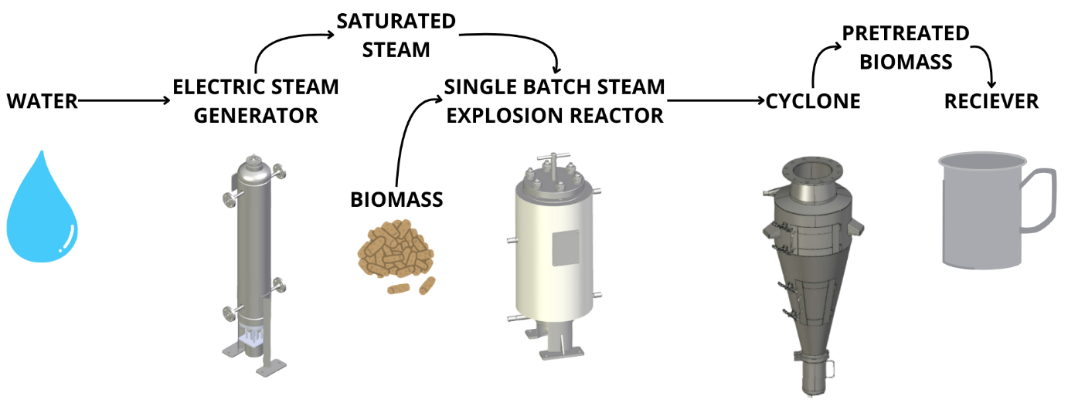
Fig. 1. Simplified scheme of steam explosion process.
Researchers primarily focus on two critical experimental parameters in this context, namely temperature (T, °C) and reaction time (t, minutes). These are often combined to generate a widely deployed metric known as the severity factor (R0), permitting analysis of the influence of hydrothermal conditions on the processed biomass. It was decided to apply the base logarithmic value of R0 herein to characterize the SE process, as defined by Equation 1 below (Overend et al., 1987):
$R_{0}=t×exp⁡\left[\left(T-100\right)/4.75\right]$ Eq. 1
Prior to the treatment, the TSRs were separated by a sieve into mesh sizes graded as 18-, 35- , and 60-mesh sizes, then humidified at approximately 85 % humidity, and 200 mL of H₂O (per 40 g of humidified TSRs) was additionally added directly into the batch reactor to stop the burning of the input material. The samples were loaded into the SE reactor, and processed at 15 bar (corresponding to 201.4 °C) for 1.5 minutes, with the corresponding samples being labelled as S18, S35, and S60. Next, the 35-grade mesh TSRs were processed at 5 (T = 158.9 °C), 10 (T = 184 °C), and 15 (T = 201.4 °C) bar for 1.5 minutes, and labeled as specimens P5, P10, and P15, respectively. Finally, the 60-grade mesh TSRs were processed at 15 bar for 0.5, 1, 1.5, and 2 minutes and designated, labeled as T0.5, T1, T1.5, and T2. A summary of the pretreatment parameters is given in Table 1. It should be noted that the pressure of the steam controls the temperature of the saturated steam (Harvey, 2001).
Table 1. The summary of parameters used during the steam explosion pretreatments.
Sample description* | Mesh [No.] | Mesh [µm] | Pressure [bar] | Time [min] | Severity [logR0]
S18 | 18 | 1000 | 15 | 1.5 | 3.07
S35 | 35 | 500 | 15 | 1.5 | 3.07
S60 | 60 | 250 | 15 | 1.5 | 3.07
P5 | 35 | 500 | 5 | 1.5 | 1.70
P10 | 35 | 500 | 10 | 1.5 | 2.53
P15 | 35 | 500 | 15 | 1.5 | 3.07
T0.5 | 35 | 500 | 10 | 0.5 | 2.05
T1 | 35 | 500 | 10 | 1.0 | 2.35
T1.5 | 35 | 500 | 10 | 1.5 | 2.53
T2 | 35 | 500 | 10 | 2.0 | 2.65
*S – fraction size as separated by the sieve; P – differences in value for pressure; T – differences in time duration.
Formation of a sludge transpires during the SE pretreatment, comprising a solid fraction (mostly cellulose and lignin) and a liquid fraction (primarily hemicellulose and degradation compounds); these arise through the actions of the saturated steam, high pressure, and temperature in the batch reactor, and rapid expansion (Ziegler-Devin et al., 2021). The pretreated TSRs (by SE) were collected from the receiver and split into the two different fractions - solid and liquid, as shown in the diagram in Fig. 2.
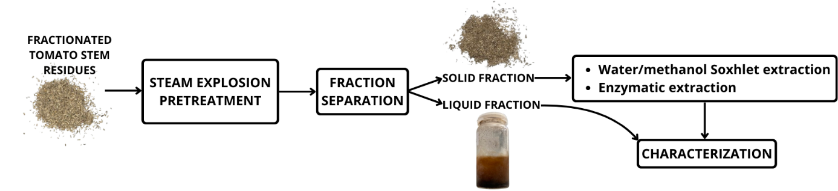
Fig. 2. Schematic description of sample processing workflow.
In order to separate the solid and liquid fractions, the samples were squeezed in a juicer-like press with a polypropylene membrane (Pegatex S; polypropylene spunbond, with an area density of 30 g/m²; PFNonwovens a.s). After separation, the solid fraction underwent additional pretreatment by Soxhlet extraction and enzymatic hydrolysis. The extracts and liquid fraction were stored at -20 °C for later characterization.
  - Structural analysis of untreated and SE pretreated solid fraction
Microstructural analysis was performed on a PhenomPro (Thermo Fisher Scientific, Germany) SEM operating at 150x and 400x magnification. Samples were subjected to critical point drying and coated in a gold-palladium layer to enhance their conductivity and the contrast of surfaces. The specimens were examined at a 5 kV accelerating voltage, enabling detailed visualization of the surface morphology of the TSRs and of structural modifications caused by the SE pretreatment.
  - Gravimetric analysis
Gravimetric determination of dissolved TSRs in the liquid and solid fractions was carried out in accordance with a manner described in a previous study by the author (Klaban et al., 2024). Analytical scales (RADWAG AS 220.R2) were employed for all measurements of mass. Empty beakers were dried at 105 °C, cooled in a desiccator and weighed (m₀), prior to being dosed with the the wet samples withdrawn directly after steam explosion. Following this, the beakers were weighed again (m₁) and subsequently dried at 105 °C for 8 h or until constant weight was obtained, after which they were cooled and weighed once more (m₂). Values for sample mass (m_{sample} = m₁ − m₀), dry mass (m_{dry} = m₂ − m₀) and volatile mass (m_{volatiles} = m_{sample} − m_{dry}) were calculated. Volatile and non-volatile content were expressed via Equations 2 and 3 below:
$Volatile content (\%) = (m_{volatiles} / m_{sample}) × 100$ Eq. 2
$Non-volatile content (\%) = 100 - Volatile content$ Eq. 3
  - Extraction of phenolic compounds from TSR
The resulting liquid fraction enriched with phenolics underwent analysis without any additional treatment (Sapci et al., 2013). The solid fraction still contained a substantial amount of cellulose and partially depolymerized lignin, however, meaning it was possible to process it more by enzymatic hydrolysis to release phenolic compounds or convert the biomass into fermentable sugars (Oliva et al., 2017; Zhu et al., 2024). As a consequence, the solid fraction was further extracted for phenolic yield by Soxhlet extraction and two methods of enzymatic extraction.
Soxhlet extraction
The TSRs (0.5 g) were subjected to Soxhlet extraction with 70% methanol for 6 hours. The extracts were centrifuged, pooled, and transferred into a 150 ml volumetric flask, which was filled to volume with methanol solution. The TSR extract solution thus obtained was filtered through a 0.45 μm microfiltration membrane and stored at −20 ℃ for later analysis as control samples.
Enzymatic hydrolysis A
Enzymatic hydrolysis of the TSRs designated “A” was performed following the standardized in vitro protocol described by Mulet-Cabero et al. (2020). The TSRs were combined with a first enzymatic mixture (comprising 2.92 g/l NaCl, 1.12 g/l KCl, 0.59 g/l NaHCO₃, 0.15 g/l CaCl₂, and 0.667 g/l pepsin). The mixture was incubated at 37 °C for 120 minutes under continuous magnetic stirring, with the pH adjusted to 2.0 by the application of HCl. Following the first phase, 10 ml of another enzymatic mixture (comprising 5.26 g/l NaCl, 0.65 g/l KCl, 0.33 g/l CaCl₂, 8.2 g/l bovine bile salt, and 4 g/l porcine pancreatin) was added into the system. The second phase took place at 37 °C for 120 minutes under continuous stirring, with pH maintained at 6.8.
Enzymatic hydrolysis B
The enzymatic hydrolysis process designated as B of TSR was performed following adherence to the protocol described by Vodicka et al. (2022). The TSRs were initially combined with the first enzymatic mixture (comprising sodium taurocholate 0.043 g/L, lecithin (soy) 0.002 g/L, pepsin 0.1 g/L, NaCl 2.0 g/L, and water up to a volume of 1000 mL). The mixture was then incubated at 37 °C for 120 minutes under continuous magnetic stirring, with the pH adjusted to 2.0 using the aid of HCl. Following the first phase, another fluid was applied at the amount of 10 mL of the second enzymatic mixture (comprising porcine bile extract 0.113 g/L, lecithin (soy) 0.222 g/L, palmitic acid 0.026 g/L, BSA 3 g/L, and pancreatin 0.1 g/L in a Tris-maleate buffer (5.5 g of Tris and 8.8 g of maleic acid, adjusted to pH 7.8 with 0.5M NaOH, totaling volume 1000 mL)). The second phase was conducted at 37 °C for 120 minutes under continuous stirring, with pH maintained at 6.8. It should be noted that hydrolysis B is established solely for experimental purposes, and it was designed primarily for laboratory-scale simulation and mechanism study. It is not intended for direct industrial application, as the protein and lipid components introduced would substantially increase downstream purification complexity and cost, rendering it economically unfeasible at scale.
The bio-accessible fraction of each enzymatic hydrolysis was obtained by centrifugation at 10,000 × g for 15 minutes at 4 °C. The obtained resulting TSR extract solution was filtered through a 0.45 μm microfiltration membrane and stored at -20 ℃ for further analyses as control samples.
  - Determination of phenolic and flavonoid content
Phenolic content
The total amount of phenolic content in the extracts was determined via the Folin-Ciocalteu method, by means of UV-Vis spectrophotometry on a SPECORD 210 Plus (Analytik Jena AG) UV-Vis spectrophotometer (Masci et al., 2016; Swain and Hillis, 1959). Gallic acid was employed as the reference for such a semi-quantitative evaluation of the phenols present. Gallic acid standard solutions (500–0.98 mg/l) were prepared as a series through serial dilution for calibration purposes. For analysis, transfer was made into polystyrene cuvettes of 0.125–0.250 ml of each extract dissolved in methanol, as well as the gallic acid standards. These specimens were supplemented with 1.25 ml of Folin-Ciocalteu reagent (9:1, v/v) and 1 ml of Na₂CO₃ solution (7.5 g/l). The cuvettes were sealed, shielded from light, and incubated at room temperature for two hours, thereby permitting the reduction of the Folin-Ciocalteu reagent by phenolic compounds, in turn giving rise to a blue colour measurable at 765 nm. Calibration curves were generated by linear regression, and the TPC was calculated and expressed as gallic acid equivalents (GAE) per gram of dry biomass (mg GAE/g dw) (Vek et al., 2024).
Flavonoid content
Total flavonoid concentrations were determined via a UV-Vis spectrophotometry method on the SPECORD 210 Plus (Analytik Jena AG) UV-Vis spectrophotometer. A volumetric flask was dosed with a mixture of 1 ml of the sample and 4 ml of distilled water, into which 0.3 ml of 5% NaNO₂ solution was added, and this was left to react for 5 minutes at room temperature. The addition of 0.3 ml of 10% AlCl₃ solution was made subsequently, and the reaction continued for a further 6 minutes. The reaction was neutralized by adding 2 ml of 1 M NaOH and 2.4 ml of distilled water, followed by thorough mixing. The absorbance was measured at 510 nm after standing at room temperature. Flavonoid concentrations were calculated as rutin equivalents (RE) per gram of dry sample weight. A rutin standard solution (1 g/l) was prepared for calibration purposes, and serial dilutions were made to obtain concentrations ranging from 0.01 to 0.8 g/l. Each calibration standard underwent the same procedure as the sample, with absorbance being gauged afterwards (Chen et al., 2020). A calibration curve was generated by plotting the absorbance readings against rutin concentration, and the flavonoid content of each sample was calculated by substituting the calibration equation with the value for absorbance. The results were expressed as milligrams of RE per gram of dry TSRs (mg RE/g).
Phenolic compound analysis
HPLC analysis was conducted on a Dionex UltiMate 3000 Series chromatograph equipped with a diode array detector (DAD) (Thermo Fisher Scientific, Germany). Chromatographic separation occurred on a Kinetex 2.6 μm C18 100 A column (150 × 4.6 mm; Phenomenex, USA) coupled with a SecurityGuard ULTRA UHPLC C18 pre-column, maintained at 30 °C. A binary solvent system, either comprising water and acetic acid or water, acetonitrile, and acetic acid, was utilized with programmed gradient elution. Detection took place at 275 nm, at an injection volume of 10 µl, and data acquisition was managed by the LC Chromeleon™ 7.2 Chromatography Data System (Thermo Fisher Scientific, Germany), enabling comprehensive qualitative and quantitative analysis of sample components.
  - Antioxidant activity assays
DPPH radical scavenging activity was evaluated by a method described in the literature (Vek et al., 2024). This necessitated mixing 200 µl of a sample with 2800 µl of 80 µM/l methanolic DPPH solution. The mixture was incubated at room temperature in the dark for 30 minutes. Absorbance was measured subsequently at 515 nm on a SPECORD 210 Plus UV-Vis spectrophotometer (Analytik Jena AG). Antioxidant activity was expressed as milligrams of Trolox equivalents (TE) per gram of dry TSRs (mg TE/g) (Hofmann et al., 2015).
  - Statistical evaluation of data
To obtain reliable data, the measurements were performed in at least three parallel replicates, and the data was presented as mean ± standard deviation. A one-way Tukey’s post-Hoc statistical analysis was performed out using HSD. P<0.05 meant statistically significant.
- Results and discussion
  - Characterization of the raw TSRs
Once harvested and dried, the TSRs were crushed by a cutting mill into pieces that could pass through a sieve of 50 mm diameter, then divided into fractions by sieve analysis. The percentages for the fractions are given in Table 2. Each fraction was subjected to SE pretreatment to compare differences in behaviour relating to size during such pretreatment.
Table 2. Distribution of particle sizes of the crushed TSRs obtained from sieve analysis.
Mesh [NO.] | Size [µm] | Percentage [%]
18 | 1000 | 45.56±0.34
35 | 500 | 29.71±0.28
60 | 250 | 20.70±0.20
Determining what primary compounds were present was crucial to assessing the sustainability of the TSRs for further processing and valorization. These included cellulose, hemicellulose, and lignin, which were quantified and compared with values reported in the literature.
The data presented in Table 3 highlight the variances in TSR composition reported in relevant studies, emphasizing the influence of factors such as plant origin, environmental conditions, and methodological differences for discerning the inherent components. The amount of lignin observed herein (19.06±0.78%) was within the range stated by Covino et al. (2020), though slightly lower than the values observed by Boundzanga et al. (2022), these being concentrations of between 20.55% and 23.23%. The content of hemicellulose (33.1±1.2%) fell within the lower level gauged by Covino et al. (2020), yet is less than that asserted by Boundzanga et al. (2022), which extended from 35.85% to 38.65%. The extent of cellulose (23.1±0.3%) was in agreement with the findings by Covino et al. (2020), but significantly below the quantity expressed by Boundzanga et al. (2022), who described concentrations of between 39.60% and 40.90%. These differences could be attributed to variations between the plants investigated, their growing conditions, and the analytical methodologies applied. For instance, Moradi and Fathi (2023) reported hemicellulose (14.5±0.27%) at an amount beneath the results of this study, suggesting that the composition of lignocellulosic biomass might depend on factors such as the conditions under which the plants are grown and their maturity.
Table 3. Chemical composition of the TSR mixture (S35) compared to different studies characterized lignin, hemicellulose and cellulose content in tomato pomace.
Reference | Lignin [%] | Hemicellulose [%] | Cellulose [%]
This study | 19.06±0.78 | 33.1±1.2 | 23.1±0.3
(Covino et al., 2020) | 10 – 25 | 30 – 60 | 20 – 40
(Boundzanga et al., 2022) | 20.55 – 23.23 | 35.85 – 38.65 | 39.60 – 40.90
(Moradi and Fathi, 2023) | 15.47±0.65 | 14.5±0.27 | 25.43±0.73
The significant lignocellulosic content in the TSRs has the potential for application in biorefineries, or in the production of antioxidants and anti-inflammatory, antimicrobial, and anticarcinogenic materials (Oak et al., 2005; Shahidi and Ambigaipalan, 2015). Moreover, fibre separation of such biomass pretreated by SE could give rise to a thermal insulation material with antibacterial and antifungal properties (Tupciauskas et al., 2024).
  - Gravimetric analysis of SE fractions
As mentioned in section 2.4, the SE process created liquid and solid fractions. Gravimetric analysis was carried out to quantify the mass distribution between these fractions, providing insight into the extent of TSR solubilization achieved during the SE process. This mass balance was crucial for assessing how effective the pretreatment had been at disrupting the lignocellulosic matrix. It was found that the liquid fraction contained dissolved non-volatile compounds from the TSRs, as hydrolyzed from the solid part during the pretreatment. The ratio of the non-volatile portions of the TSRs in the liquid to solid fractions is illustrated in Fig. 3. An average of 18% of the pretreated TSRs had dissolved in the liquid fraction, a slightly higher amount than in a study by Cöpür et al. (2012), where the mean percentage of the dissolved material was 14.8%.
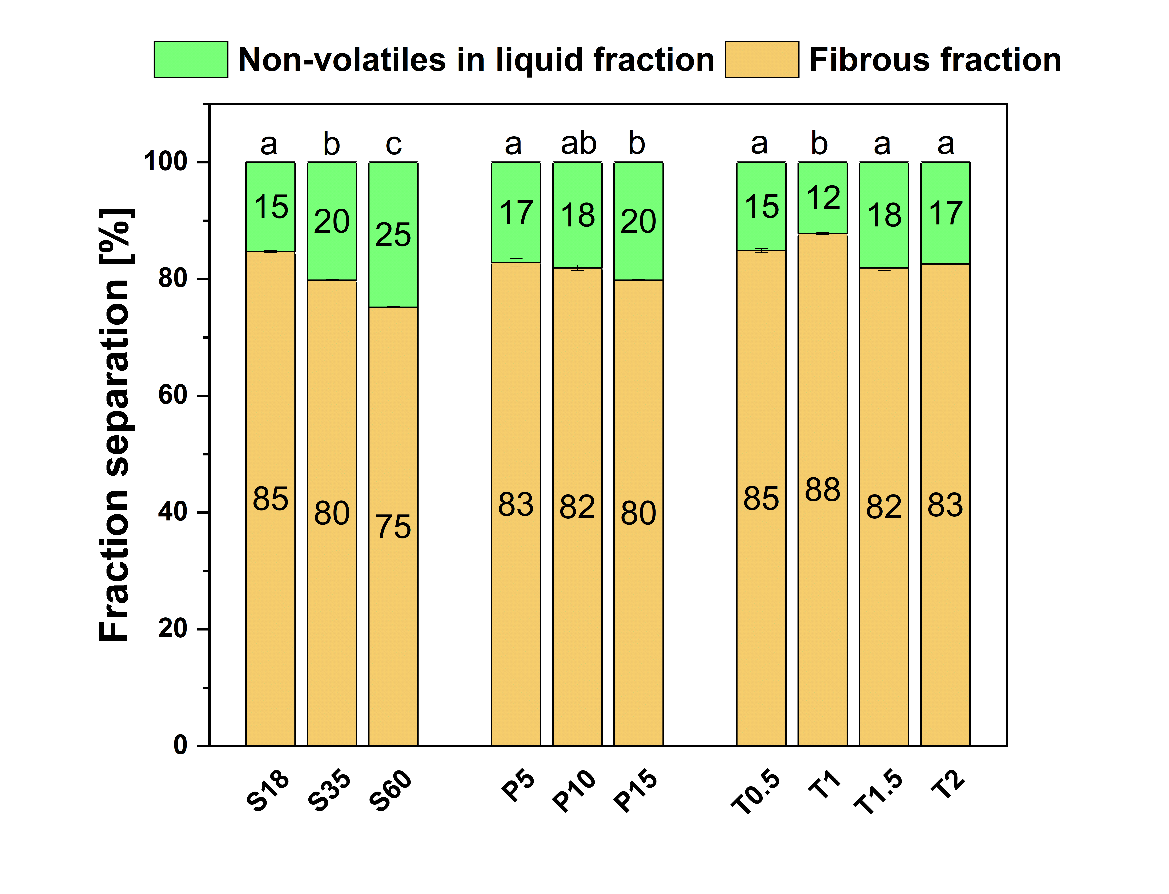
Fig. 3. Proportion of TSR matter dissolved by SE into the liquid fraction to the remaining solid-fibrous portion (total dry content). The liquid contained hydrolyzed compounds (both volatile and non-volatile), whereas the other fraction contained solid, partially hydrolyzed compounds. The pretreatment conditions comprised sieve size (S), pressure (P) and time (T). Different letters within each experimental group (Sn, Pn, Tn) indicate statistically significant differences (Tukey HSD, p < 0.05).
The gravimetric analysis revealed the influence the parameters of the pretreatment exerted, notably that a decrease in particle size directly affected the solubility of the TSRs. Such a reduction in particle size, at a severity factor of logR0 = 3.06, raised their solubility. A notable aspect was that increasing the pressure, applying corresponding severity factors (logR0 = 1.70; 2.53; 3.07), and maintaining the same particle size (S35) failed to alter the volume of non-volatiles in the liquid fraction significantly. Likewise, no major change was made in this regard by extending the duration of the pretreatment and adopting the corresponding severity factors (logR0 = 2.05; 2.35; 2.52; 2.65), with the particle size remaining identical (S35).
  - Effect of SE pretreatment on the microstructure of the TSRs
The mechanisms of SE constitute complex thermomechanical processes capable of dissolving the microstructure of biomass. Based on research on woody biomass, this investigation of TSRs corroborated such transformative actions. Previous studies on lignocellulosic biomass have clarified the mechanisms of SE, notably a differential in pressure that instantaneously disrupts cellular structures. Although originally described for woody biomass, the same principles demonstrate remarkable transferability to agricultural residues, such as tomato biomass (Fu et al., 2017; Zhang and Cai, 2006).
SE pretreatment alters the microstructure of the given material, transforming it initially through exposure to high temperature and pressure, followed by an instantaneous drop in the latter, thereby promoting both permeability and access to cellular components. A PhenomPro SEM was employed herein to analyse such structural changes in the TSRs. The micrograph in Fig. 4 of the original untreated TSR S30 sample was generated at 150x magnification, while Fig. 5 (taken at 400x magnification) details elements variously modified by the SE procedure.
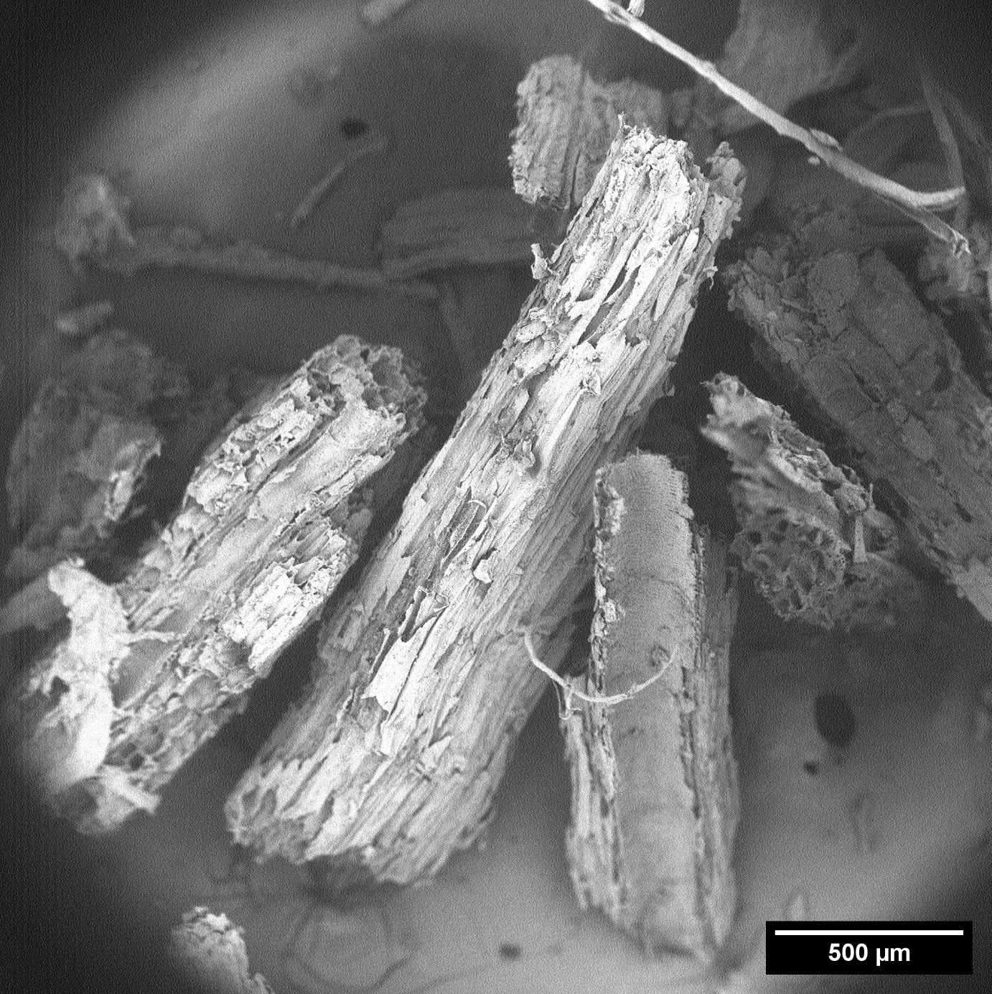
Fig. 4. Structural overview of the untreated TSR S30 sample at 150x magnification.
Fig. 5 contains micrographs of TSR biomass specimens at 400x magnification, showing levels of mechanical disruption to their cellular architectures, which represent reference points for later morphological changes.
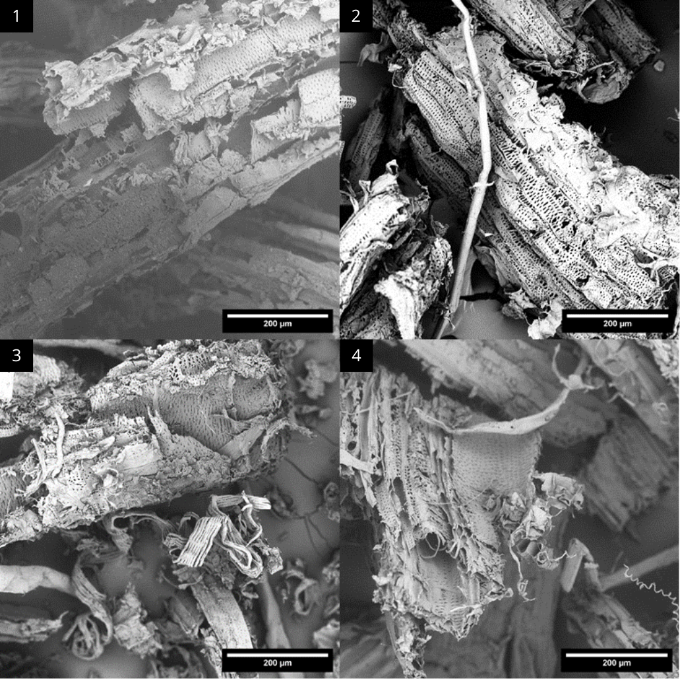
Fig. 5. Visualization of structures captured at 400x magnification, imaging the breadth of alterations exerted by the various pretreatments. Micrographs of (1) the initial TSR sample, (2) sample S60, (3) sample P15 and (4) sample T2.
Fig. 5 details morphological differences between certain TSRs before and after SE pretreatments. The original, unprocessed sample possessed a mechanically disrupted structure, with the other pretreated ones showing more fibrillation in their arrangements. Sample S60 exhibited partial delamination, and its surface was rougher, indicating moderate disruption had occurred. Sample P15, subjected to the pressure of 15 bar, demonstrated pronounced fibre separation, rupture to its walls, and the exposure of inner cell layers, suggesting increased access to the biomass. Sample T2, treated for 2 minutes, presented significant fibrillation and the collapse of cell structures, reflecting the major impact of treatment time on the degradation of fibres.
High-resolution SEM at 400x magnification enabled the visualization of microstructural changes induced by the SE pretreatment. The consequent findings indicate the procedure is capable of modifying TSR microstructures, potentially raising the efficiency of biomass conversion. Further research would be necessary to correlate the ensuing microstructural alterations with its capacity for biochemical transformation, in addition to optimizing its parameters for maximum biomass valorization.
  - Phenolic and flavonoid content determination
Analysis of Total phenolic content determination in the TSR extracts by UV-Vis spectroscopy in TSR extracts
Polyphenols, complex secondary metabolites abundant in plants, exist at various concentrations in different parts of plants. The amount of phenol found in TSRs is not consistent, as can be seen in Fig. 6. Phenolics ranging between 5 and 25 mg GAE per g, yet potentially more than in the fruit of the tomato plant for reason of an inherent defence mechanism (Bulgari et al., 2015; Khoddami et al., 2013).
Fig. 6 contains data on TPC, as determined by comprehensive analysis of the SE pretreated TSRs. Apart from UV-Vis spectrophotometry, other methods were employed to obtain the findings, namely Soxhlet extraction (for control purposes) and two forms of enzymatic hydrolysis (denoted A and B) of the pretreated TSRs. Samples that had undergone the SE pretreatment demonstrated higher phenolic yields, varying as per the given conditions. A notable trend was a correlation between a decrease in TSR particle size and a consequent sharp rise in phenolic yield. Such a reduction in dimension would make sense if it served as an additional pretreatment procedure, albeit with a requirement for extra energy utilization (more milling and/or sieving of the biomass). Raising pressure also increased the phenolic content gained. Little variance was discerned, though, between the 35-mesh TSR specimens pretreated for different periods of time. Total phenolic yield initially went up in connection with this, but later dropped. It would appear that this parameter exerted only a minor effect on the samples of this size, with any divergence likely being related to the uncertainty of the method. The highest phenolic yields were achieved by enzymatic method B with 60-mesh TSRs. The maximum seen for them was 5.9 times higher than for the untreated specimen, i.e. 21.01 mg GAE/ g of TSRs. These results indicate that SE facilitates the dissolution of phenolics from the lignocellulosic matrix in an effective manner, while the adopted enzymatic methods heighten the yield even more.
The enhanced efficiency of Enzymatic hydrolysis B in releasing phenolic compounds can be attributed to several synergistic mechanisms. Bovine Serum Albumin (BSA) acts as a phenolic carrier that prevents the re-adsorption of liberated compounds back onto the biomass surface. BSA forms reversible complexes with phenolics, which stabilizes them and enhances their solubility in the aqueous phase (Rai et al., 2018). Furthermore, the inclusion of bile salts and lecithin serves to emulsify apolar components into micelles, which 'capture' and stabilize polyphenols, protecting them from degradation during pH transitions and enhancing overall bioaccessibility (Stinco et al., 2022). Bile salts also act as permeability enhancers by inducing phospholipid-disordering and thinning the structural integrity of residual cell membranes. This membranolytic activity increases biomass permeability, allowing enzymes like pepsin and pancreatin to achieve deeper penetration and better access to bound phenolic-polysaccharide complexes (Ozkan et al., 2020). These combined effects particularly favor the release and stabilization of more amphiphilic and structurally complex phenolics, such as chlorogenic acid, thereby explaining its higher recovery under Scheme B conditions.
The two-phase nature of Scheme B (starting at pH 2.0 and moving to pH 6.8) further maximizes the release of specific phenolic classes. While acidic conditions favor total phenolic recovery, the neutral environment in the second phase (pH 6.8–7.5) specifically increases the recovery of flavonoids and stabilizes pH-sensitive compounds like chlorogenic acid (Colombo et al., 2023; Dawidowicz & Typek, 2011. In contrast, simpler phenolic acids such as 3,4-dihydroxybenzoic acid, which are less effectively stabilized within micellar systems, may be more susceptible to oxidative degradation or structural transformation during prolonged exposure to near-neutral pH. Consequently, their lower yield in Scheme B may reflect reduced stability under these conditions rather than limited release.
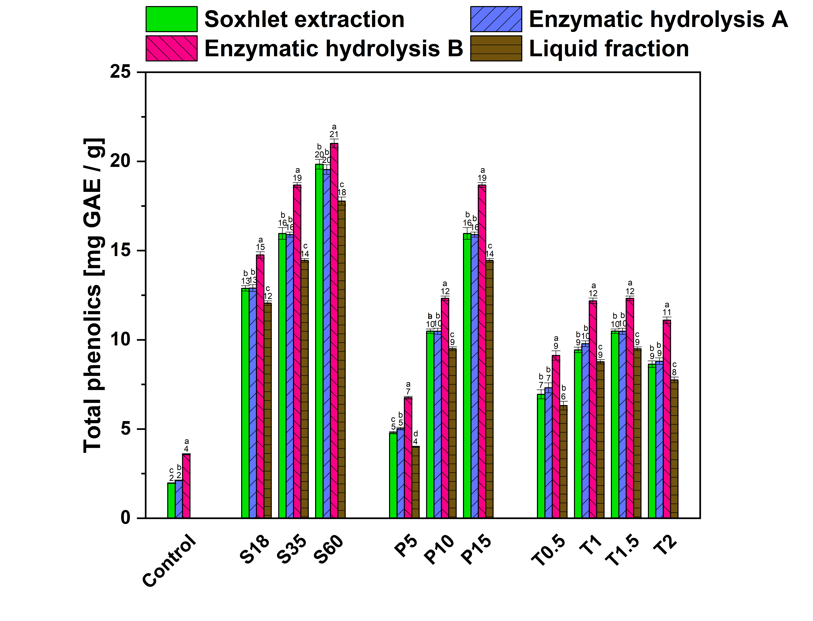
Fig. 6. Effects of three SE factors (pressure, duration and particle size) on total phenolic content in the TSRs, expressed in mg GAE per g of biomass, quantified by UV-Vis spectrophotometry. Pretreatment conditions comprised 3 modes - sieve (S), pressure (P) and time (T). As a control, the untreated sample S35 was considered. Different letters within each experimental group (Sn, Pn, Tn) indicate statistically significant differences (Tukey HSD, p < 0.05).
Determination of flavonoid content in the TSR extracts by Uv-Vis spectroscopy
The data in Fig. 7 were gathered by analysing the total flavonoid content extracted from the pretreated TSRs. The methods adopted were Soxhlet extraction and forms of enzymatic hydrolysis denoted A and B, with yields reported as mg RE per g of biomass. The different mesh sizes applied affected the content of phenol discerned. The highest flavonoid yield for all the samples was observed for the 60-mesh sieve at 7.97±0.19 mg RE/ g of TSRs, equal to 1.5 times more than the untreated control sample which underwent enzymatic hydrolysis B. Smaller TSR particles resulting from the lesser dimensions of mesh stood out in this regard, too. For instance, the control at mesh size 18 yielded more flavonoids. Varying the pressure applied (5-15 bar) also led to rises in the flavonoids obtained, although prolonging the duration (0.5-2 min) of the SE pretreatment had little effect. These findings show that the SE procedure strongly promotes the dissolution of flavonoids from TSRs.
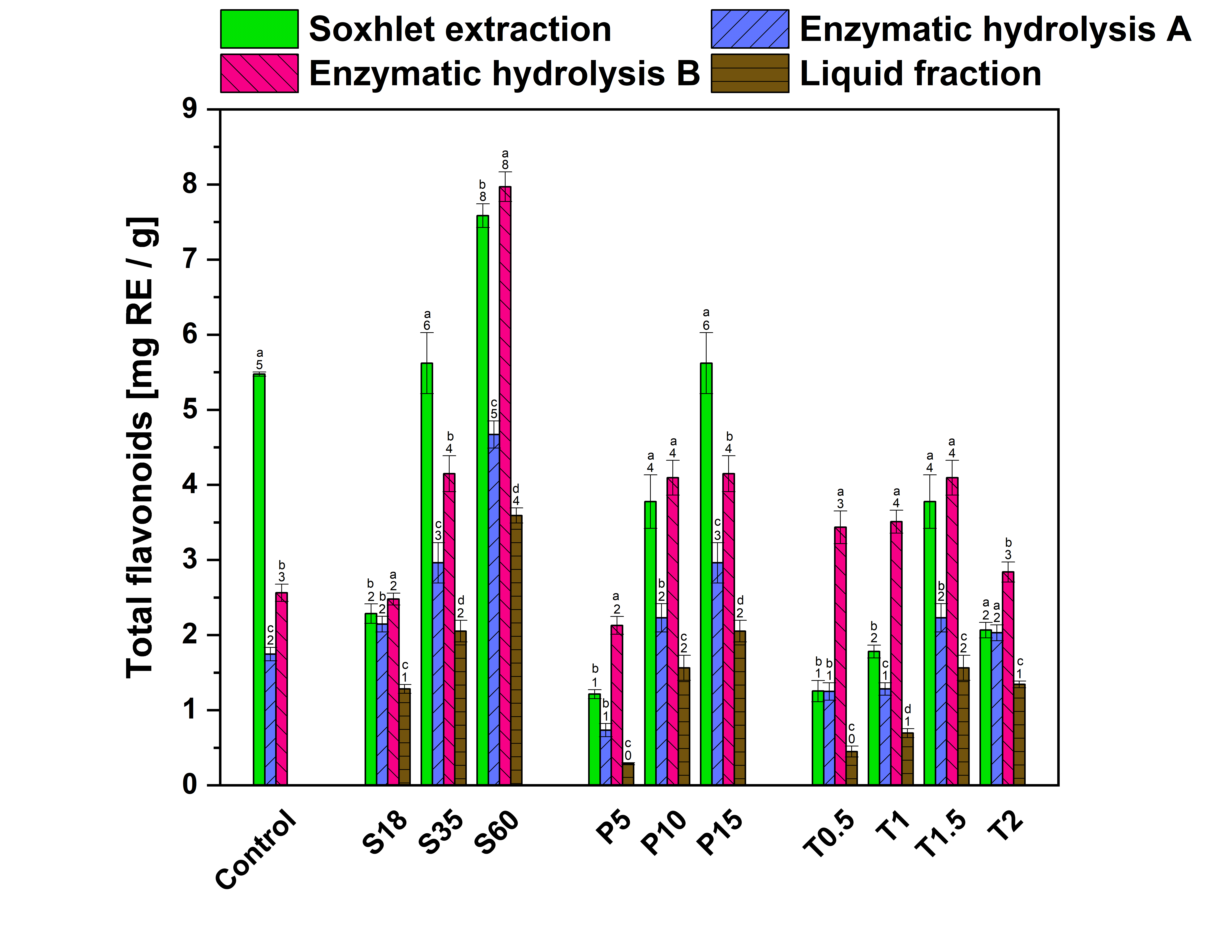
Fig. 7. Effects of SE, pressure, duration and particle size on total flavonoid content in the TSRs, expressed in mg RE per g of biomass. Pretreatment conditions comprised 3 modes - sieve (S), pressure (P) and time (T). As a control, the untreated sample S35 was considered. Different letters within each experimental group (Sn, Pn, Tn) indicate statistically significant differences (Tukey HSD, p < 0.05).
Researchers state that flavonoid content in tomato varies from 2 to 6 mg AE per g (Dūma et al., 2018; Mokhtar et al., 2015), and that an optimized SE pretreatment procedure can enhance the release of bioactive compounds from plant biomass (Martín-Sampedro et al., 2011; Wan et al., 2022a). The influence of the SE pretreatment on the phenolic and flavonoid content varies to some extent. Li et al. (2020) state it is capable of destroying cell wall structures, thereby promoting the solubilization of bioactive compounds, especially flavonoids. They also describe an increase in flavonoid content in sea buckthorn pomace from 7.14 to 24.74 mg catechin equivalence per g (Li et al., 2018), in line with the results stated herein. Certain chemical bonds, such as glycosidic bonds and hydrogen bonds, can be cleaved by the instantaneous change in pressure during the SE pretreatment, however, leading to the decomposition of phenolics (Chen et al., 2020). Since a reduction in total phenolic and flavonoid content occurs following the procedure, it would appear that its effectiveness may depend on the particular phenolic composition and structural characteristics of the biomass matrix. This includes the type of lignin present and how it interacts with cell wall components, which in turn influence the solubilization and stability of phenolic compounds during processing (Gong et al., 2021).
The data presented in this study agree with or exceed values in the literature for similar agricultural residues treated by comparable methods. For instance, Cui et al. (2023) asserted that SE pretreatment yielded 30–55 mg GAE/g Dw of phenolics from grape pomace. Research on olive pomace revealed that the same procedure gave rise to a phenolic content of 25–50 mg GAE/g Dw (Gullón et al. 2018). The SE pretreatment of Hangbaiju (Hangzhou white chrysanthemum) by Zhu et al. (2024) yielded up to 13 mg CAE/g of phenolics. Other lignocellulosic residues from various agricultural sources (e.g. wheat straw and rice husks) treated with SE produced 15–40 mg GAE/g of phenolics (Cara et al., 2008; Wan et al., 2022a). The results presented herein show that enzymatic hydrolysis B, when applied to a solid fraction of steam-exploded TSRs (S60), released an additional 21.01 mg GAE/g, hence a cumulative yield of approximately 40 mg GAE/g. This combined effect significantly exceeds the average phenolic content typically reported for untreated TSRs (5–25 mg GAE/g), highlighting the strong synergistic potential of SE followed by the enzymatic process. It should be noted, though, that the methodologies employed in the studies above may have differed and thereby affected the values reported.
Steam explosion mechanism of lignin
Bioactive compounds, e.g. phenolics and flavonoids, arise through the transformation of lignin during the given SE procedure. Critical to recovering such substances, this form of thermomechanical treatment initially involves exposing biomass to high-pressure steam, followed by rapid decompression that causes physical and chemical modification to the structure of the lignin. The intense heat and pressure have the potential to cleave β-O-4 ether bonds which can be observed in Fig. 8 that are prevalent in the polymer matrix of lignin, leading to partial depolymerization and the formation of lower molecular weight lignin fragments and soluble phenolic compounds (Jamari et al., 2019; Nader et al., 2022). However, lignin might repolymerize under certain conditions pertaining to the hydrothermal properties of SE, consequently impacting the yield of the bioactive compounds (Li et al., 2007).
SE hydrolyses hemicellulose into its monosaccharide components, primarily pentoses and hexoses. Under the acidic conditions generated during SE, sugars undergo dehydration (Bao et al., 2024); specifically, hexoses like glucose could isomerize and cyclize, giving rise to compounds such as quinic acid. The latter serves as a precursor for the synthesis of chlorogenic acid (CGA), the ester formed through the esterification of quinic acid with caffeic acid. CGA is known for its antioxidant activity and health benefits (Gong et al., 2021), and has anti-inflammatory properties.
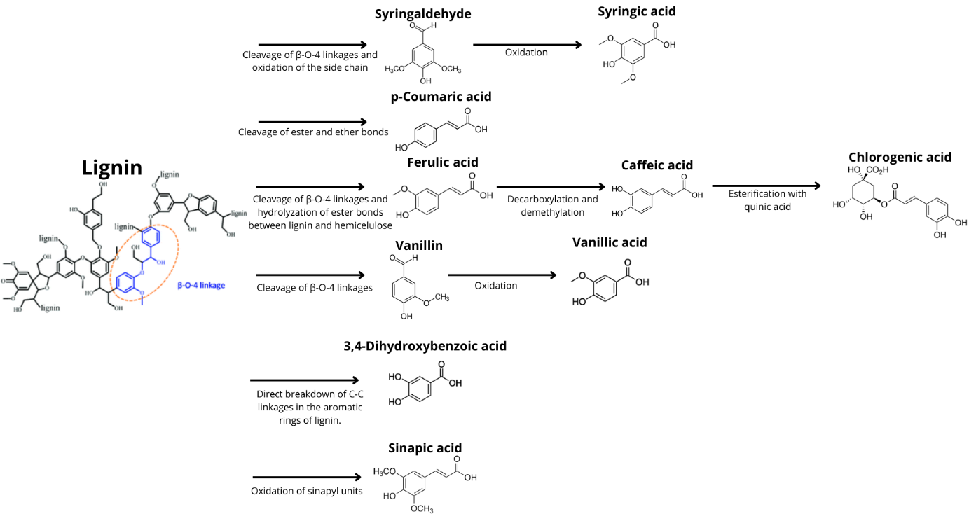
Fig. 8. Cleavage pathways of lignin during SE – generation of phenolic acids (Auxenfans et al., 2017; Liu et al., 2019; Oleszek et al., 2023; Ribeiro et al., 2023).
Phenolic compound analysis
Studies by Ali et al. (2020) and Flores et al. (2021) have proven that phenolic compounds are found in tomatoes. In order to clarify the influence of SE pretreatment on their release and extraction, HPLC-DAD was conducted on extracts to quantify the phenolics present in original and pretreated samples, applying the Soxhlet and enzymatic processes (A and B) to this end. Table 4 summarizes a subset of five phenolic compounds discerned, namely CGA, ferulic acid, 3,4-dihydroxybenzoic acid, vanillic acid and catechin, selected for their quantitative relevance, response to the pretreatment and biological significance. Such data reflect how the combined procedure of SE and enzymatic hydrolysis affects the release of hydroxycinnamic and hydroxybenzoic acids, as well as flavonoids.
The complete analytical data set is provided in the supplementary materials. It includes HPLC-DAD chromatograms of 18 phenolic standards (Fig. S1) and their corresponding chromatographic parameters and retention times (Table S2). To illustrate the extraction profiles, Fig. S3 shows representative chromatograms for fraction S60 across all four processing methods (liquid fraction (LF), enzymatic hydrolysis A (A), enzymatic hydrolysis B (B), and Soxhlet extraction (E)). The total quantified yields (expressed in µg/g dry TSR) for selected phenolic acids and catechin across all sieve fractions and processing parameters (S, P, and T) are summarized in Table S4. While the chromatograms in Fig. S3 show the complete polyphenolic profile, Table S4 focuses on the predominant compounds, including p-coumaric, ferulic, sinapic, chlorogenic, 3,4-dihydroxybenzoic, vanillic, and syringic acids.
Table 4. Influence of SE-pretreatment parameters on the yield (in µg/g of dry TSRs) of specific phenolic compounds in the TSRs. Quantification comprised HPLC-DAD of the liquid fraction, as to the forms of enzymatic hydrolysis (A and B) and Soxhlet extraction applied. The SE conditions for each compound corresponded to the set of parameters (particle size, pressure and time) that exerted the greatest overall effect. The control sample denoted S35 contained untreated TSRs.
Compound | Chlorogenic acid [µg/g] | Ferulic acid [µg/g] | 3,4-dihydroxybenzoic acid [µg/g] | Vanillic acid [µg/g] | Catechin [µg/g]
Liquid fraction
Control | N/A | N/A* | N/A | N/A | N/A
S60 | 0.27±0.01 | 0.43±0.02 | 2.5±0.1 | 1.8±0.1 | 6.5±0.3
P15 | 5.6±0.3 | 0.209±0.004 | 2.6±0.1 | 1.9±0.1 | 4.2±0.3
T2 | <LOQ* | <LOQ* | 1.5±0.1 | 0.98±0.01 | 1.76±0.01
Enzymatic hydrolysis A

Control | 5.94±0.06 | 0.212±0,005 | 2.63±0.02 | 1.64±0.06 | <LOQ*
S60 | 19.9±0.3 | 0.131±0.003 | 2.4±0.1 | 2.3±0.1 | 11.3±0.8
P15 | 8.4±0.2 | 0.18±0.01 | 1.7±0.1 | 0.80±0.04 | 3.1±0.2
T2 | 15.3±0.5 | 0.77±0.03 | 0.69±0.03 | 1.83±0.09 | 6.43±0.06
Enzymatic hydrolysis B

Control | 3.9±0.2 | 0.391±0.008 | 2.6±0.2 | 2.5±0.1 | 3.9±0.2
S60 | <LOQ* | 0.228±0.008 | <LOQ* | 3.5±0.2 | 10.6±0.4
P15 | 7.3±0.2 | 0.148±0.003 | 0.42±0.02 | 2.69±0.02 | 1.85±0.03
T2 | 6.30±0.06 | 0.79±0.03 | <LOQ* | 3.1±0.1 | 5.5±0.1
Soxhlet extraction

Control | 17.2±0.2 | 0.092±0.002 | 6.5±0.2 | 1.9±0.1 | 9.0±0.5
S60 | 31±1 | 0.41±0.02 | 5.1±0.1 | 3.0±0.2 | 20.9±0.3
P15 | 37±2 | 0.32±0.01 | 4.7±0.2 | 3.3±0.1 | 11.5±0.1
T2 | 51±3 | 0.44±0.01 | 2.5±0.3 | 4.2±0.1 | 21±1
*N/A (not applicable) – all liquid fractions were pretreated by SE
*LOQ (limit of quantification) = 0.04 – 0.08 %
The most abundant compound detected was CGA, as typically bound in the cell wall of the plant. While Soxhlet extraction of the untreated TSRs yielded 17.2 µg/g, the T2 SE-treated sample (at 15 bar for 2 min.; S35) notably exceeded it at 51 µg/g. This is important because CGA possesses antihypertensive and antidiabetic properties, showing potential impact against metabolic syndrome (Santana-Gálvez et al., 2017), and due to enhanced stability it is promising compound for food preservatives (Nam et al., 2017) or crosslinking in biopolymers (Sapuła et al., 2024). A similar finding was seen for catechin, with Soxhlet extraction engendering 9 µg/g for the untreated TSRs and 23 µg/g for the T2 sample. Catechin is a strong antioxidant with potential benefits in cardiovascular health and cognitive function (Mita et al., 2024). Since it is not from monolignols but flavan-3-ols, the SE pressure and steam break down proanthocyanidins by cleaving interflavan bonds to release monomeric catechin units (Zhang et al., 2021). These results confirm that SE facilitates access to phenolic compounds by cleaving ester and ether bonds in the lignin-carbohydrate complex, which are otherwise bound within the lignocellulosic matrix (Serrano et al., 2017; Wan et al., 2022a). Such enhanced release under Soxhlet conditions indicates that SE contributes to depolymerization and solvent accessibility, though does not promote aqueous solubilization during the pretreatment.
A distinct pattern was seen for p-coumaric acid, in contrast. Greater concentrations of it were detected in the liquid fraction with increased severity factors, highlighting its susceptibility to thermal solubilization. The p-coumaric acid has strong antimicrobial activity and is used in active packaging to improve UV protection and shelf life (Virgili et al., 2022), or as a browning inhibitor in fresh-cut produce (Jiang and Penner, 2022). This reinforces the finding that p-coumaric acids exist in less complex esterified forms, which are easily cleaved and released into the aqueous phase during SE (Auxenfans et al., 2017).
A declining trend was also observed for 3,4-dihydroxybenzoic acid (3,4-DHBA), as untreated samples possessed a higher concentration of it (6.5 µg/g, Soxhlet), followed by consistent reduction alongside a parallel rise in severity factor. While 3,4-DHBA shows potential in protecting cells from oxidative damage, can also be used to improve the properties of polymers (e.g. mechanical) and positively affect degradation rates (Mouren et al., 2024).
The highest concentration for the Soxhlet control specimen pertained to ferulic acid, evincing its vulnerability to raised pressure and temperature during exposure. It has anti-ageing properties and is used as a bio-based monomer for polyesters (Zhang et al., 2024). While evidence exists that protocatechuic acid can sometimes leach into the liquid fraction during the SE process, its overall yield decreases in line with a rise in severity (Wan et al., 2022b).
Vanillic and syringic acids presented mixed distributions. The latter was moderately distributed in each extract and in the liquid phase, suggesting partial solubility. Vanillic acid has neuroprotective effects and benefits for metabolic syndrome and serves also as a bio-based monomer for polymer synthesis and as an additive in polymers for food packaging (Magiera et al., 2025, Vannini et al., 2023). In contrast, syringic acid remained largely in the solid phase, with a greater recovery rate by Soxhlet and moderate by enzymatic extractions. It is used in rubber to prevent oxidation and in edible coatings to prolong shelf life (Chen et al., 2022; Yang et al., 2019). These patterns imply that certain phenolics undergo degradation or structural rearrangement under SE conditions, especially at elevated severities (Akizuki et al., 2023).
Sinapic acid which can be used to strengthen biopolymer films and a stabilizing agent in edible coatings (Rabiej-Kozioł et al., 2022, Crouvisier-Urion et al., 2019), somewhat resists direct extraction during SE pretreatment, though. The greatest yields were achieved by enzymatic extraction B of the SE pretreated sample S35 (4.8 µg/g) (Wang et al., 2021).
This study emphasizes how the SE pretreatment influences the phenolic profiles of TSRs. The biomass is altered through the degradation, conversion and solubilization of phenolic compounds under varying procedural conditions, which directly affect the bioactive potential of the TSR matrix. SE pretreatment significantly enhances the release and bioaccessibility of phenolic compounds from the biomass, by disrupting the cell wall matrix and enabling the extraction of bound phenolics during enzymatic hydrolysis (Das et al., 2020). The transformations observed, such as the degradation of 3,4-dihydroxybenzoic acid, highlight the effects of SE and conditions of enzymatic hydrolysis on phenolic profiles. These findings suggest that SE-treated TSRs show potential as a valuable source of bioaccessible phenolics with functional and health benefits, and that further research is warranted.
Based on the specific phenolic profile of the extracts obtained in this study, targeted application scenarios can be proposed beyond general functional food uses. High-pressure steam explosion combined with enzymatic hydrolysis (particularly Scheme B) resulted in extracts with significant yields of chlorogenic acid and catechins. Given that CGA has a strong propensity to concentrate at oil-water interfaces, these extracts are exceptionally suited as natural antioxidant stabilizers for emulsion-based systems (e.g., salad dressings or functional beverages), where they can effectively inhibit lipid oxidation (Meireles et al., 2019). Furthermore, for fractions containing higher relative amounts of ferulic acid and p-coumaric acid, the most promising application lies in the development of bioactive food packaging. Studies have shown that ferulic acid improves the mechanical strength and barrier properties of biodegradable films, such as PLA or PHBV, while providing intrinsic antimicrobial activity (Moll & Chiralt, 2023; Ordoñez et al., 2022). These specific applications are further supported by the physiological benefits of these compounds, such as the modulation of gut microbiota and intestinal barrier function, suggesting their potential as ingredients in gastrointestinal-targeted functional foods (Huang et al., 2025; Tian et al., 2022).
While this study focuses on laboratory-scale optimization, the ecological and circular economy benefits of the proposed strategy are significant. Compared to conventional solvent-based extraction methods, which typically require large volumes of organic solvents, longer processing times, and additional solvent recovery steps, SE represents a more environmentally friendly and potentially energy-efficient alternative due to its rapid processing and minimal chemical input. SE is an energy-efficient pretreatment due to the rapid disruption of the lignocellulosic matrix without the necessity for toxic organic solvents, which reduces the overall environmental footprint compared to conventional chemical methods. From an economic perspective, the lignin-rich residues recovered after SE represent a valuable by-product rather than waste. In a biorefinery context, these residues can be valorized as a low-cost fuel source to generate process heat and power, analogous to energy integration strategies employed in kraft pulp mills (Ziegler-Devin et al., 2021). Furthermore, although enzymatic hydrolysis B utilizes laboratory-grade reagents like BSA and bile salts to provide mechanistic clarity, industrial-scale implementation would transition to industrial-grade enzymes and recycling protocols to ensure economic feasibility. By utilizing TSR, which is an abundant and currently underutilized agricultural waste, this process directly supports circular economy goals by converting low-value biomass into high-value antioxidant extracts suitable for industrial applications
In general, the SE pretreatment has the capacity to boost phenolic yields over those for untreated TSRs, whereby an increased amount of phenolic is recoverable, depending on the compound in question. Combining high pressure with a fine grind of the biomass and an adopted form of extraction maximizes the release of bioactive compounds, e.g. chlorogenic and catechin. These results align with those of prior studies on lignocellulosic residues, and indicate that TSRs are valorized effectively through SE pretreatment and selective fractionation (Wan et al., 2022a; Yu et al., 2023). This approach would be applicable for a concept at a biorefinery for producing high-value antioxidant phenolics from agricultural waste.
  - Antioxidant activity of TSR extracts
Past investigations have shown that phenolic compounds exhibit strong antioxidant properties, functioning as radical scavengers and reducing agents that protect against oxidative stress (Kumar and Goel, 2019). In this study, the antioxidant activity of the TSRs was evaluated by a DPPH assay, and the results are presented in Fig. 9. The antioxidant activity is expressed as TE per gram of sample, where a higher TE value indicates greater antioxidant capacity (Song et al., 2024). The SE-pretreated TSRs exhibited enhanced antioxidant activity, their facility for DPPH radical scavenging exceeding (by 2.1 times) the original untreated samples (9.74, 12.18 and 13.45 TE mg/g, respectively).
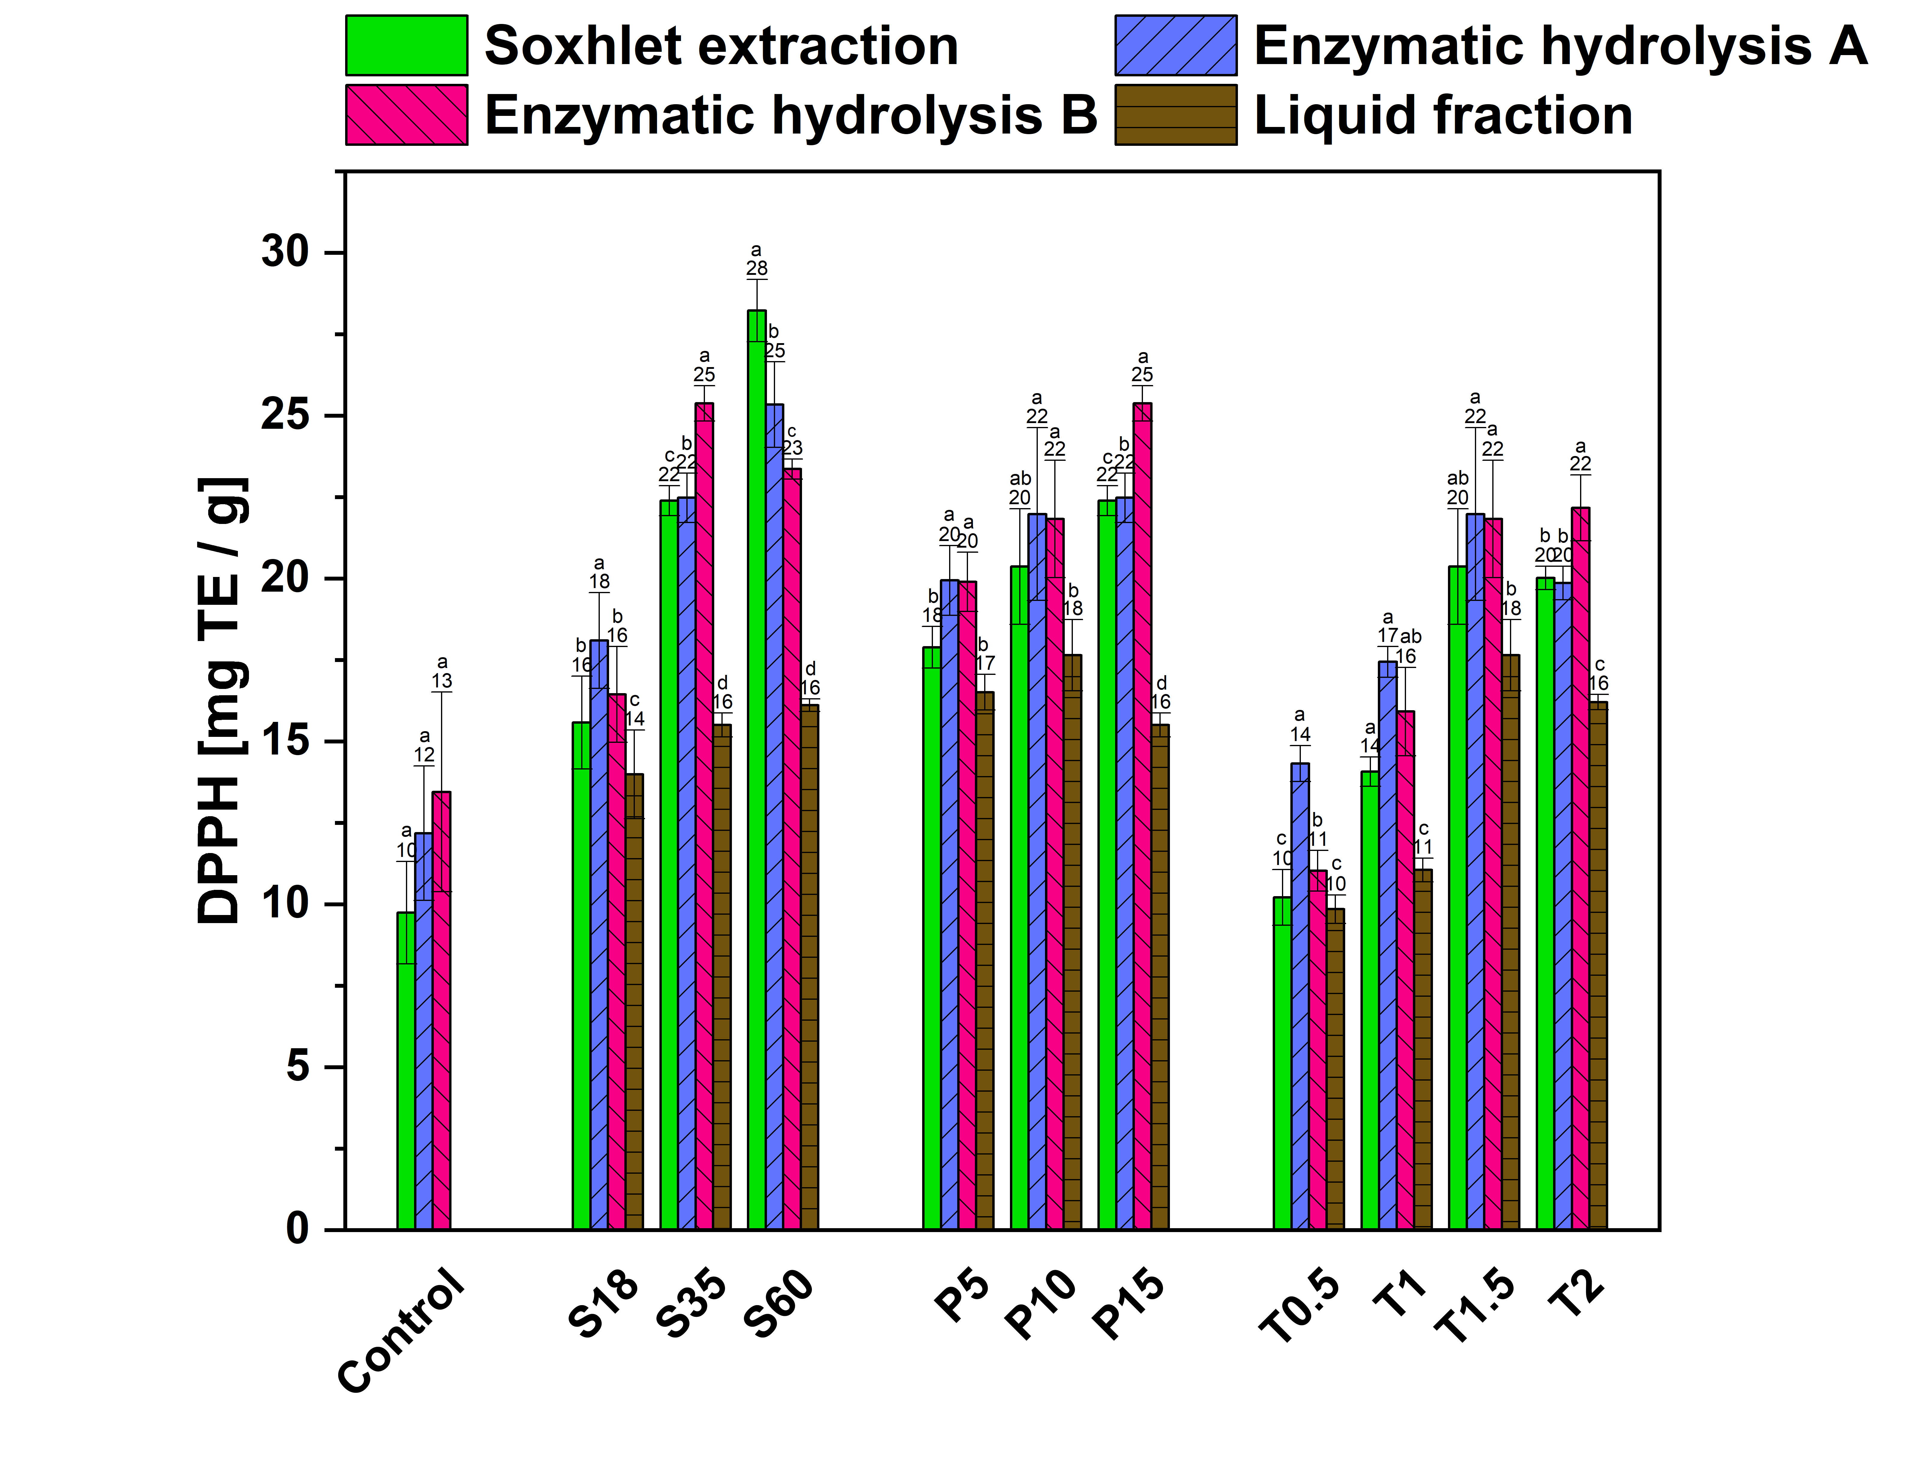
Fig. 9. Effects of explosion pressure, duration and particle size on the antioxidant activity of TSRs expressed in mg TE/g. The pretreatment conditions comprised 3 modes - sieve (S), pressure (P) and time (T). The untreated sample S35 served as a control. Different letters within each experimental group (Sn, Pn, Tn) indicate statistically significant differences (Tukey HSD, p < 0.05).
SE has been reported to improve the efficiency of polyphenolic extraction by disrupting the lignocellulosic matrix, facilitating access to phenolics and enhancing their bioavailability (Wan et al., 2022a). Such pretreatment boosted the antioxidant potential of all the samples. For instance, those denoted S18, S35 and S60 exhibited rises of up to 16.1±0.2 mg TE/g (S60), while the pressure differences exerted on P5, P10 and P15 brought about increases of up to 17.6±1.7 (P10 and T1.5). Varying the parameter of time (T0.5, T1, T1.5 and T2) failed to exert any significant effect, compared to the control sample, prior to carrying out enzymatic hydrolysis. In fact, a slight decrease in antioxidant activity was observed, dropping from 17.6 (T1.5) to 16.2 (T2) mg TE/g of TSRs.
Once enzymatic hydrolysis A and B had been performed, another rise in DPPH activity was observed. For example, the S35 and P15 samples exhibited the highest activity at 25.4±0.5 mg TE/g, followed closely by S60 (23.4±0.3 mg TE/g). These findings support the hypothesis that enzymatic hydrolysis processes are able to release bound polyphenols, boosting the level of antioxidant activity. Indeed, enzymatic hydrolysis may cause the extraction of esterified or insoluble phenolics, thereby furthering their bioavailability (Neffe-Skocińska et al., 2023). The results reported herein on the antioxidant activity of TSRs after SE pretreatment and enzymatic hydrolysis agree somewhat with prior related research. Investigations by Liu et al. (2021) on Prinsepia utilis (Royle fruits) and Gomes et al. (2019) on grapes both highlighted a gradual rise in antioxidant capacity following simulated processes of enzymatic hydrolysis. This suggests that such an environment of hydrolysis has the potential to intensify the availability or bioactivity of antioxidant compounds in certain plant-based materials. Returning to the current investigation, since certain samples demonstrated improvement in or maintained their antioxidant activity while others diminished in this regard, it would seem that the specific parameters applied during the pretreatment and enzymatic hydrolysis procedures significantly affected the consequent antioxidant profile of the TSRs.
Notably, samples with a high TPC (e.g. S60 and P15) also showed elevated antioxidant activity, lending support to the strong correlation between phenolic concentration and radical scavenging capacity. These results accentuate the potential of SE within a strategy for valorization that aims to recover antioxidant-rich extracts from TSRs.
- Conclusion
Carrying out SE pretreatment of agricultural residues (herein a harvest of Solanum lycopersicum) shows promise in connection with sustainable valorization and circular economy applications. It was observed that SE effectively altered the content and profiles of the phenolic compounds in the tested tomato residues. Optimal conditions for this comprised both the smallest particle size and high pressure, bringing about the greatest yields of 21.01±0.24 mg GAE/g of phenolics and 7.97±0.19 mg RE/g of flavonoids with statistical significance across all treatments (p<0.05). Combining SE with additional hydrolysis boosted the amounts obtained of certain phenolics, such as acids (chlorogenic, p-coumaric, 3,4-dihydrobenzoic, ferulic, syringic, sinapic and vanillic) and catechin. Enzymatic hydrolysis facilitated higher yields of phenolic and flavonoid compounds, in addition to raising the level of antioxidant activity, in comparison with a typical method of solvent extraction (e.g. Soxhlet). The enhanced recovery of bioactive compounds highlights the potential applicability of this approach for the production of natural antioxidants suitable for food formulation, active and bio-based packaging materials, and integration into biorefinery platforms for high-value ingredient recovery. It should be acknowledged that the single-factor experimental design employed herein does not demonstrate potential interactions between variables, and future studies should therefore consider multivariate optimization approaches, such as response surface methodology, to identify global optimum conditions. Future research should focus on scaling up the process, techno-economic evaluation, optimizing industrial parameters and gaining further insight into the thermochemical mechanisms involved. This would raise the sustainability and economic viability of the approach in the production of high-value bioactive compounds
CRediT authorship contribution statement
Vladimír Sedlařík: Writing- reviewing and editing, Supervision, Resources, Project administration, Funding acquisition, Conceptualization. Jakub Klaban: Investigation, Formal analysis, Conceptualization, Writing- reviewing and editing, Methodology, Writing- original draft. Tomáš Šopík: Data curation, Formal analysis. Monika Strašáková: Formal analysis. Klaudia Chmelová: Formal analysis. Fernando Bonfiglio: Writing- reviewing and editing, Methodology, Conceptualization.
Declaration of Competing Interest
All authors declare that there is no conflict of interest regarding the publication of this paper.
Acknowledgments
The authors are grateful to the Centre of Polymer Systems, at Tomas Bata University in Zlín (TBU).
Funding sources
This study was developed in the framework of the the Internal Grant Agency of TBU in Zlín [grant no IGA/CPS/2025/002], DKRVO [grant no RP/CPS/2024-28/002] with the financial support of the Ministry of Education, Youth and Sports of the Czech Republic, European Just Transition Fund within the Operational Programme: Just Transition under the aegis of the Ministry of the Environment of the Czech Republic, project CirkArena number CZ.10.03.01/00/22_003/0000045 and the Ministry of Education Youth and Sports of the Czech Republic, Operational Programme Johannes Amos Comenius OP JAC "Application potential development in the field of polymer materials in the context of circular economy compliance (POCEK)", number CZ.02.01.01/00/23_021/0009004; the European Union Horizon 2020 research and innovation programme MSCA-RISE, in connection with a specific project entitled "Sustainable production of cellulose-based products and additives to be used in SMEs and rural areas" and CELISE [grant agreement no 101007733].
Ethics statement
There are no studies with humans/animals in this work.
Declaration of Competing Interest
The authors declare that they have no known competing financial interests or personal relationships that could have influenced the findings reported in this paper.
Glossary
TSR
Tomato stem residues
SE
Steam explosion
BSA
Bovine serum albumin
TPC
Total phenolic content
HPLC
High-performance liquid chromatography
DAD
Diode array detector
SEM
Scanning electron microscopy
DPPH
2,2-Diphenyl-1-picrylhydrazyl
RE
Rutin equivalents
TE
Trolox equivalents
GAE
Gallic acid equivalents
Dw
Dry weight
CGA
Chlorogenic acid
3,4-DHBA
3,4-dihydroxybenzoic acid
S
Particle size
P
Pressure
T
Residence time
m
Mass
Data availability
Data will be made available on request.
Declaration of generative AI and AI-assisted technologies in the writing process.
During the preparation of this work, the author(s) used gemini.google.com in order to improve the readability and language of the manuscript. After using this tool/service, the author(s) reviewed and edited the content as needed and take(s) full responsibility for the content of the published article.
References
Akizuki, S., Suzuki, H., Fujiwara, M., Toda, T. (2023). Impacts of steam explosion pretreatment on semi-continuous anaerobic digestion of lignin-rich submerged macrophyte. Journal of Cleaner Production, 385, 135377. https://doi.org/10.1016/J.JCLEPRO.2022.135377
Ali, M.Y., Sina, A.A.I., Khandker, S.S., Neesa, L., Tanvir, E.M., Kabir, A., Khalil, M.I., Gan, S.H. (2020). Nutritional Composition and Bioactive Compounds in Tomatoes and Their Impact on Human Health and Disease: A Review. Foods, 10, 45. https://doi.org/10.3390/FOODS10010045
Almeida, P. V., Gando-Ferreira, L.M., Quina, M.J. (2024). Tomato Residue Management from a Biorefinery Perspective and towards a Circular Economy. Foods, Vol. 13, Page 1873 13, 1873. https://doi.org/10.3390/FOODS13121873
Auxenfans, T., Crônier, D., Chabbert, B., Paës, G. (2017). Understanding the structural and chemical changes of plant biomass following steam explosion pretreatment. Biotechnology for Biofuels, 10, 1–16. https://doi.org/10.1186/S13068-017-0718-Z
Bao, Y., Du, Z., Liu, X., Liu, H., Tang, J., Qin, C., Liang, C., Huang, C., Yao, S. (2024). Furfural production from lignocellulosic biomass: one-step and two-step strategies and techno-economic evaluation. Green Chemistry, 26, 6318–6338. https://doi.org/10.1039/D4GC00883A
Baral, N. R., & Shah, A. (2017). Comparative techno-economic analysis of steam explosion, dilute sulfuric acid, ammonia fiber explosion and biological pretreatments of corn stover. Bioresource Technology, 232, 331–343. https://doi.org/10.1016/j.biortech.2017.02.068
Bolaño, J., Insuasty, D.C., Rodríguez, D., Grande-Tovar, J.D., Potential, C.D., Copolovici, M., Carolina, D., Insuasty, D., David, J., Macías, R., Grande-Tovar, C.D. (2024). Potential Use of Tomato Peel, a Rich Source of Lycopene, for Cancer Treatment. Molecules, Vol. 29, Page 3079 29, 3079. https://doi.org/10.3390/MOLECULES29133079
Boundzanga, H.M., Cagnon, B., Roulet, M., de Persis, S., Vautrin-Ul, C., Bonnamy, S. (2022). Contributions of hemicellulose, cellulose, and lignin to the mass and the porous characteristics of activated carbons produced from biomass residues by phosphoric acid activation. Biomass Conversion and Biorefinery, 12, 3081–3096. https://doi.org/10.1007/S13399-020-00816-9
Bulgari, R., Cocetta, G., Trivellini, A., Vernieri, P., Ferrante, A. (2015). Biostimulants and crop responses: a review. Biological Agriculture & Horticulture, 31, 1–17. https://doi.org/10.1080/01448765.2014.964649
Cara, C., Ruiz, E., Ballesteros, M., Manzanares, P., Negro, M.J., Castro, E. (2008). Production of fuel ethanol from steam-explosion pretreated olive tree pruning. Fuel, 87, 692–700. https://doi.org/10.1016/J.FUEL.2007.05.008
Chang, J.M., Joye, I.J. (2024). Improving agricultural sustainability – A review of strategies to valorize tomato plant residues (TPR). Waste Management, 190, 88–101. https://doi.org/10.1016/J.WASMAN.2024.08.031
Chen, H. (2015). Lignocellulose biorefinery feedstock engineering. Lignocellulose Biorefinery Engineering, 37–86. https://doi.org/10.1016/B978-0-08-100135-6.00003-X
Chen, S., Wang, Xiujuan, Wang, Xueting, Zheng, W., He, S., Song, M., Wang, H. (2022). The Influence of Syringic Acid and Erucic Acid on the Antioxidant Properties of Natural Rubber: Experimental and Molecular Simulation Investigations. Polymers, 14, 4254. https://doi.org/10.3390/POLYM14204254
Chen, Y., Shan, S., Cao, D., Tang, D. (2020). Steam flash explosion pretreatment enhances soybean seed coat phenolic profiles and antioxidant activity. Food Chemistry, 319, 126552. https://doi.org/10.1016/J.FOODCHEM.2020.126552
Chowdhury, P., Mahi, N.A., Yeassin, R., Chowdhury, N.U.R., Farrok, O. (2025). Biomass to biofuel: Impacts and mitigation of environmental, health, and socioeconomic challenges. Energy Conversion and Management: X, 25, 100889. https://doi.org/10.1016/J.ECMX.2025.100889
Colombo, R., Paolillo, M., Frosi, I., Ferron, L., & Papetti, A. (2023). Effect of the simulated digestion process on the chlorogenic acid trapping activity against methylglyoxal. Food & Function, 14(1), 541–549. https://doi.org/10.1039/D2FO02778J
Cöpür, Y., Özyürek, Ö., Tozluoglu, A., Kütük, S. (2012). Enzymatic digestibility of tomato, pepper, and eggplant stalks mixture: BioResources [WWW Document]. URL https://bioresources.cnr.ncsu.edu/resources/enzymatic-digestibility-of-tomato-pepper-and-eggplant-stalks-mixture/ (accessed 11.8.24).
Covino, C., Sorrentino, A., Di Pierro, P., Roscigno, G., Vece, A.P., Masi, P. (2020). Lignocellulosic fibres from enzyme-treated tomato plants: Characterisation and application in paperboard manufacturing. International Journal of Biological Macromolecules, 161, 787–796. https://doi.org/10.1016/J.IJBIOMAC.2020.06.077
Crouvisier-Urion, K., Regina Da Silva Farias, F., Arunatat, S., Griffin, D., Gerometta, M., Rocca-Smith, J.R., Weber, G., Sok, N., Karbowiak, T. (2019). Functionalization of chitosan with lignin to produce active materials by waste valorization. Green Chemistry, 21, 4633–4641. https://doi.org/10.1039/C9GC01372E
Cui, W., Wang, Y., Sun, Z., Cui, C., Li, H., Luo, K., Cheng, A. (2023). Effects of steam explosion on phenolic compounds and dietary fiber of grape pomace. LWT, 173, 114350. https://doi.org/10.1016/J.LWT.2022.114350
Czech Statistical Office. (2023). Final Harvest Fig.s - 2023 | Products [WWW Document]. URL https://csu.gov.cz/produkty/final-harvest-Fig.s-2023 (accessed 1.15.25).
Das, P.R., Islam, M.T., Lee, S.H., Lee, M.K., Kim, J.B., Eun, J.B. (2020). UPLC-DAD-QToF/MS analysis of green tea phenolic metabolites in their free, esterified, glycosylated, and cell wall-bound forms by ultra-sonication, agitation, and conventional extraction techniques. LWT, 127, 109440. https://doi.org/10.1016/J.LWT.2020.109440
Dawidowicz, A. L., & Typek, R. (2011). The influence of pH on the thermal stability of 5-O-caffeoylquinic acids in aqueous solutions. European Food Research and Technology 2011 233:2, 233(2), 223–232. https://doi.org/10.1007/S00217-011-1513-X
Dillon, A. (2024). 2024 POST SEASON GLOBAL TOMATO CROP UPDATE [WWW Document]. URL https://www.morningstarco.com/2024-post-season-global-tomato-crop-update/ (accessed 4.29.25).
Dūma, M., Alsina, I., Dubova, L., Erdberga, I. (2018). Bioactive compounds in tomatoes at different stages of maturity. Proceedings of the Latvian Academy of Sciences, Section B: Natural, Exact, and Applied Sciences, 72, 85–90. https://doi.org/10.2478/PROLAS-2018-0014
Elwakeel, K. Z., Elgarahy, A. M., Alghamdi, H. M., & El-Qelish, M. (2023). Recycling of catering waste for sequential production of biohydrogen and biomethane; pre-treatments, batch, and continuous mode studies. Journal of Environmental Chemical Engineering, 11(5), 110955. https://doi.org/10.1016/j.jece.2023.110955
Flores, I.R., Vásquez-Murrieta, M.S., Franco-Hernández, M.O., Márquez-Herrera, C.E., Ponce-Mendoza, A., del Socorro López-Cortéz, M. (2021). Bioactive compounds in tomato (Solanum lycopersicum) variety saladette and their relationship with soil mineral content. Food Chemistry, 344, 128608. https://doi.org/10.1016/J.FOODCHEM.2020.128608
Fu, F., Lin, L., Xu, E. (2017). Functional pretreatments of natural raw materials. Advanced High Strength Natural Fibre Composites in Construction, 87–114. https://doi.org/10.1016/B978-0-08-100411-1.00004-2
Gomes, T.M., Toaldo, I.M., Haas, I.C. da S., Burin, V.M., Caliari, V., Luna, A.S., de Gois, J.S., Bordignon-Luiz, M.T. (2019). Differential contribution of grape peel, pulp, and seed to bioaccessibility of micronutrients and major polyphenolic compounds of red and white grapes through simulated human digestion. Journal of Functional Foods, 52, 699–708. https://doi.org/10.1016/J.JFF.2018.11.051
Gong, J., Weng, Q., Sun, J., Wang, D., Qiu, S., Li, L., Chu, B., Xiao, G., Liu, S., Zheng, F. (2021). Steam explosion pretreatment alters the composition of phenolic compounds and antioxidant capacities in Chrysanthemum morifolium Ramat cv. “Hangbaiju.” Journal of Food Processing and Preservation, 45. https://doi.org/10.1111/JFPP.15376
Gregor-Svetec, D., Vodnik, Ž., Gale, T., Kavčič, U. (2024). Tomato Plant Residues, a Sustainable Fiber Source for Cardboard Packaging. Sustainability, Vol. 16, Page 7801 16, 7801. https://doi.org/10.3390/SU16177801
Gullón, B., Gullón, P., Eibes, G., Cara, C., De Torres, A., López-Linares, J.C., Ruiz, E., Castro, E. (2018). Valorisation of olive agro-industrial by-products as a source of bioactive compounds. Science of The Total Environment, 645, 533–542. https://doi.org/10.1016/j.scitotenv.2018.07.155
Harvey, A. (2001). Steam Tables, Encyclopedia of Physical Science and Technology, Third Edition, [online], https://tsapps.nist.gov/publication/get_pdf.cfm?pub_id=906704 (Accessed March 4, 2026)
Hofmann, T., Nebehaj, E., Stefanovits-Bányai, É., Albert, L. (2015). Antioxidant capacity and total phenol content of beech (Fagus sylvatica L.) bark extracts. Industrial Crops and Products, 77, 375–381. https://doi.org/10.1016/J.INDCROP.2015.09.008
Huang, P., Hu, J., Yang, K., Tian, B., (2025). Digestion characteristics of Changyanning formula and its regulatory effect on fecal microbiota and metabolites during in vitro fermentation. Fitoterapia 187, 106949. https://doi.org/10.1016/J.FITOTE.2025.106949
Jamari, S.S., Nawi, M.N., Amin, K.N.M., Sulaiman, N.S., Mohamad, S., Zakaria, J., Ali, M.F., Shaarani, S.M., Nafsun, A.I., Supian, M.A.F., Mohammad, R., Hassan, Z. (2019). Investigation of Lignin Content Removal in the Steam Exploded Empty Fruit Bunch Fibers. Key Engineering Materials, 797, 218–223. https://doi.org/10.4028/WWW.SCIENTIFIC.NET/KEM.797.218
Jiang, S., Penner, M.H. (2022). The Effect of p-Coumaric Acid on Browning Inhibition in Potato Polyphenol Oxidase-Catalyzed Reaction Mixtures. Foods, Vol. 11, Page 577 11, 577. https://doi.org/10.3390/FOODS11040577
Khoddami, A., Wilkes, M.A., Roberts, T.H. (2013). Techniques for analysis of plant phenolic compounds. Molecules, 18, 2328–2375. https://doi.org/10.3390/MOLECULES18022328
Klaban, J., Meile, K., Godina, D., Tupciauskas, R., Berzins, A., Andze, L., Sedlarik, V. (2024). Evaluation of value-added by-products from steam explosion lignocellulosic biomass (Triticum aestivum, Zea mays, and Phragmites australis). Industrial Crops and Products, 222, 119443. https://doi.org/10.1016/J.INDCROP.2024.119443
Kumar, N., Goel, N. (2019). Phenolic acids: Natural versatile molecules with promising therapeutic applications. Biotechnology Reports, 24, e00370. https://doi.org/10.1016/J.BTRE.2019.E00370
Laranjeira, T., Costa, A., Faria-Silva, C., Ribeiro, D., Ferreira de Oliveira, J.M.P., Simões, S., Ascenso, A. (2022). Sustainable Valorization of Tomato By-Products to Obtain Bioactive Compounds: Their Potential in Inflammation and Cancer Management. Molecules, 27. https://doi.org/10.3390/molecules27051701
Li, J., Henriksson, G., Gellerstedt, G. (2007). Lignin depolymerization/repolymerization and its critical role for delignification of aspen wood by steam explosion. Bioresource Technology, 98, 3061–3068. https://doi.org/10.1016/J.BIORTECH.2006.10.018
Li, K., Yao, F., Xue, Q., Fan, H., Yang, L., Li, X., Sun, L., Liu, Y. (2018). Inhibitory effects against α-glucosidase and α-amylase of the flavonoids-rich extract from Scutellaria baicalensis shoots and interpretation of structure–activity relationship of its eight flavonoids by a refined assign-score method. Chemistry Central Journal, 12, 1–11. https://doi.org/10.1186/S13065-018-0445-Y
Li, W., Zhang, X., He, X., Li, F., Zhao, J., Yin, R., Ming, J. (2020). Effects of steam explosion pretreatment on the composition and biological activities of tartary buckwheat bran phenolics. Food & Function, 11, 4648–4658. https://doi.org/10.1039/D0FO00493F
Liu, S., Bai, L., Van Muyden, A.P., Huang, Z., Cui, X., Fei, Z., Li, X., Hu, X., Dyson, P.J. (2019). Oxidative cleavage of β-O-4 bonds in lignin model compounds with a single-atom Co catalyst. Green Chemistry, 21, 1974–1981. https://doi.org/10.1039/C9GC00293F
Liu, X., Shi, J., Yi, J., Zhang, X., Ma, Q., Cai, S. (2021). The effect of in vitro simulated gastrointestinal digestion on phenolic bioaccessibility and bioactivities of Prinsepia utilis Royle fruits. LWT, 138, 110782. https://doi.org/10.1016/J.LWT.2020.110782
Magiera, A., Kołodziejczyk-Czepas, J., Olszewska, M.A. (2025). Antioxidant and Anti-Inflammatory Effects of Vanillic Acid in Human Plasma, Human Neutrophils, and Non-Cellular Models In Vitro. Molecules, Vol. 30, Page 467 30, 467. https://doi.org/10.3390/MOLECULES30030467
Martín-Sampedro, R., Martín, J.A., Eugenio, M.E., Revilla, E., Villar, J.C. (2011). Steam explosion treatment of Eucalyptus globulus wood: Influence of operational conditions on chemical and structural modifications. Bioresources, 6, 4922–4935. https://doi.org/10.15376/BIORES.6.4.4922-4935
Masci, A., Coccia, A., Lendaro, E., Mosca, L., Paolicelli, P., Cesa, S. (2016). Evaluation of different extraction methods from pomegranate whole fruit or peels and the antioxidant and antiproliferative activity of the polyphenolic fraction. Food Chemistry, 202, 59–69. https://doi.org/10.1016/J.FOODCHEM.2016.01.106
Meireles, M., Losada-Barreiro, S., Costa, M., Paiva-Martins, F., Bravo-Díaz, C., & Monteiro, L. S. (2019). Control of antioxidant efficiency of chlorogenates in emulsions: modulation of antioxidant interfacial concentrations. Journal of the Science of Food and Agriculture, 99(8), 3917–3925. https://doi.org/10.1002/JSFA.9615
Mesfun, S., Matsakas, L., Rova, U., & Christakopoulos, P. (2019). Technoeconomic Assessment of Hybrid Organosolv–Steam Explosion Pretreatment of Woody Biomass. Energies 2019, Vol. 12, 12(21). https://doi.org/10.3390/en12214206
Mita, S.R., Husni, P., Putriana, N.A., Maharani, R., Hendrawan, R.P., Dewi, D.A. (2024). A Recent Update on the Potential Use of Catechins in Cosmeceuticals. Cosmetics, Vol. 11, Page 23 11, 23. https://doi.org/10.3390/COSMETICS11010023
Mokhtar, M., Soukup, J., Donato, P., Cacciola, F., Dugo, P., Riazi, A., Jandera, P., Mondello, L. (2015). Determination of the polyphenolic content of a Capsicum annuum L. extract by liquid chromatography coupled to photodiode array and mass spectrometry detection and evaluation of its biological activity. Journal of Separation Science, 38, 171–178. https://doi.org/10.1002/JSSC.201400993
Moll, E., & Chiralt, A. (2023). Polyhydroxybutyrate-co-hydroxyvalerate (PHBV) with Phenolic Acids for Active Food Packaging. Polymers 2023, Vol. 15, 15(21). https://doi.org/10.3390/POLYM15214222
Moradi, E., Fathi, M. (2023). Production of cellulose nanocrystals from tomato pomace as a food waste and their application for stabilizing of Pickering emulsions. Bioactive Carbohydrates and Dietary Fibre, 30, 100378. https://doi.org/10.1016/J.BCDF.2023.100378
Mosier, N., Wyman, C., Dale, B., Elander, R., Lee, Y.Y., Holtzapple, M., Ladisch, M. (2005). Features of promising technologies for pretreatment of lignocellulosic biomass. Bioresource Technology, 96, 673–686. https://doi.org/10.1016/J.BIORTECH.2004.06.025
Mouren, A., Pollet, E., Avérous, L. (2024). Synthesis and Assessment of Novel Sustainable Antioxidants with Different Polymer Systems. Polymers, 16, 413. https://doi.org/10.3390/POLYM16030413
Mulet-Cabero, A.I., Egger, L., Portmann, R., Ménard, O., Marze, S., Minekus, M., Le Feunteun, S., Sarkar, A., Grundy, M.M.L., Carrière, F., Golding, M., Dupont, D., Recio, I., Brodkorb, A., Mackie, A. (2020). A standardised semi-dynamic in vitro digestion method suitable for food – an international consensus. Food & Function, 11, 1702–1720. https://doi.org/10.1039/C9FO01293A
Nader, S., Brosse, N., Khadraoui, M., Fuentealba, C., Ziegler-Devin, I., Quilès, F., El-Kirat-Chatel, S., Mauret, E. (2022). A low-cost environmentally friendly approach to isolate lignin containing micro and nanofibrillated cellulose from Eucalyptus globulus bark by steam explosion. Cellulose, 29, 5593–5607. https://doi.org/10.1007/S10570-022-04632-4
Nam, S.H., Ko, J.A., Jun, W., Wee, Y.J., Walsh, M.K., Yang, K.Y., Choi, J.H., Eun, J.B., Choi, J., Kim, Y.M., Han, S., Nguyen, T.T.H., Kim, D. (2017). Enzymatic synthesis of chlorogenic acid glucoside using dextransucrase and its physical and functional properties. Enzyme and Microbial Technology, 107, 15–21. https://doi.org/10.1016/J.ENZMICTEC.2017.07.011
Neffe-Skocińska, K., Karbowiak, M., Kruk, M., Kołożyn-Krajewska, D., Zielińska, D. (2023). Polyphenol and antioxidant properties of food obtained by the activity of acetic acid bacteria (AAB) – A systematic review. Journal of Functional Foods, 107, 105691. https://doi.org/10.1016/J.JFF.2023.105691
Oak, M.H., El Bedoui, J., Schini-Kerth, V.B. (2005). Antiangiogenic properties of natural polyphenols from red wine and green tea. The Journal of Nutritional Biochemistry, 16, 1–8. https://doi.org/10.1016/j.jnutbio.2004.09.004
Oleszek, M., Kowalska, I., Bertuzzi, T., Oleszek, W. (2023). Phytochemicals Derived from Agricultural Residues and Their Valuable Properties and Applications. Molecules, 28, 342. https://doi.org/10.3390/MOLECULES28010342
Oliva, J.M., Negro, M.J., Manzanares, P., Ballesteros, I., Chamorro, M.Á., Sáez, F., Ballesteros, M., Moreno, A.D. (2017). A Sequential Steam Explosion and Reactive Extrusion Pretreatment for Lignocellulosic Biomass Conversion within a Fermentation-Based Biorefinery Perspective. Fermentation, Vol. 3, Page 15 3, 15. https://doi.org/10.3390/FERMENTATION3020015
Ordoñez, R., Atarés, L., & Chiralt, A. (2022). Antilisterial action of PLA films with ferulic acid as affected by the method of incorporation. Food Bioscience, 49, 101865. https://doi.org/10.1016/J.FBIO.2022.101865
Ouatmani, T., Haddadi-Guemghar, H., Hadjal, S., Boulekbache-Makhlouf, L., Madani, K. (2023). Tomato by-products: A potentially promising bioresource for the recovery of bioactive compounds and nutraceuticals. Nutraceutics from Agri-Food By-Products, 137–171. https://doi.org/10.1002/9781394174867.CH5
Overend, R.P., Chornet, E., Gascoigne, J.A. (1987). Fractionation of Lignocellulosics by Steam-Aqueous Pretreatments. Philosophical Transactions of the Royal Society of London. Series A, Mathematical and Physical Sciences, 321, 523–536. https://doi.org/10.1098/rsta.1987.0029
Ozkan, G., Kostka, T., Esatbeyoglu, T., & Capanoglu, E. (2020). Effects of Lipid-Based Encapsulation on the Bioaccessibility and Bioavailability of Phenolic Compounds. Molecules 2020, Vol. 25, 25(23). https://doi.org/10.3390/MOLECULES25235545
Panagiotopoulou, M., Papadaki, S., Missirli, T., Thanassoulia, I., Krokida, M. (2022). Exploring the Valorisation Potential of Tomato Cultivation By-Products in the Frame of Circular Economy. Waste and Biomass Valorization, 13, 3957–3972. https://doi.org/10.1007/S12649-022-01786-X
Pinto, D., Ferreira, A.S., Lozano-Castellón, J., Laveriano-Santos, E.P., Lamuela-Raventós, R.M., Vallverdú-Queralt, A., Delerue-Matos, C., Rodrigues, F. (2023). Exploring the Impact of In Vitro Gastrointestinal Digestion in the Bioaccessibility of Phenolic-Rich Chestnut Shells: A Preliminary Study. Separations, 10, 471. https://doi.org/10.3390/SEPARATIONS10090471
Rabiej-Kozioł, D., Tymczewska, A., Szydłowska-Czerniak, A. (2022). Changes in Quality of Cold-Pressed Rapeseed Oil with Sinapic Acid Ester-Gelatin Films during Storage. Foods, Vol. 11, Page 3341 11, 3341. https://doi.org/10.3390/FOODS11213341
Rao, M.M., Botsa, S.M., Rao, T.P., Goddu, S.R., Vijayasanthi, C. (2024). A comprehensive review on agricultural waste production and onsite management with circular economy opportunities. Discover Sustainability, 5, 1–13. https://doi.org/10.1007/S43621-024-00492-z
Rai, S., Kureel, A. K., Dutta, P. K., & Mehrotra, G. K. (2018). Phenolic compounds based conjugates from dextran aldehyde and BSA: Preparation, characterization and evaluation of their anti-cancer efficacy for therapeutic applications. International Journal of Biological Macromolecules, 110, 425–436. https://doi.org/10.1016/J.IJBIOMAC.2017.11.049
Ribeiro, A.M., Santos, A.I., Veiga, F., Figueiras, A. (2023). Lignin nanoparticle–based nanocomposite hydrogels for biomedical applications. Functional Nanocomposite Hydrogels: Synthesis, Characterization, and Biomedical Applications, 69–90. https://doi.org/10.1016/B978-0-323-99638-9.00003-4
Santana-Gálvez, J., Cisneros-Zevallos, L., Jacobo-Velázquez, D.A. (2017). Chlorogenic Acid: Recent Advances on Its Dual Role as a Food Additive and a Nutraceutical against Metabolic Syndrome. Molecules, Vol. 22, Page 358 22, 358. https://doi.org/10.3390/MOLECULES22030358
Sapci, Z., Morken, J., Linjordet, R. (2013). An investigation of the enhancement of biogas yields from lignocellulosic material using two pretreatment methods: Microwave irradiation and steam explosion: BioResources [WWW Document]. URL https://bioresources.cnr.ncsu.edu/resources/an-investigation-of-the-enhancement-of-biogas-yields-from-lignocellulosic-material-using-two-pretreatment-methods-microwave-irradiation-and-steam-explosion/ (accessed 5.2.25).
Sapuła, P., Zając, P., Pielichowski, K., Raftopoulos, K.N., Bialik-Wąs, K. (2024). Impact of a Bio-Cross-Linking Agent Obtained from Spent Coffee Grounds on the Physicochemical and Thermal Properties of Gelatin/Κ-Carrageenan Hydrogels. Materials, Vol. 17, Page 4724 17, 4724. https://doi.org/10.3390/MA17194724
Serrano, A., Fermoso, F.G., Alonso-Fariñas, B., Rodríguez-Gutierrez, G., Fernandez-Bolaños, J., Borja, R. (2017). Phenols recovery after steam explosion of Olive Mill Solid Waste and its influence on a subsequent biomethanization process. Bioresource Technology, 243, 169–178. https://doi.org/10.1016/J.BIORTECH.2017.06.093
Sežun, M., Karlovits, I., Kavčič, U. (2023). Chemical and enzymatic deinking efficiency of agricultural and industrial waste fiber-based paper packaging. Journal of the Science of Food and Agriculture, 103, 1069–1076. https://doi.org/10.1002/JSFA.11815
Shahidi, F., Ambigaipalan, P. (2015). Phenolics and polyphenolics in foods, beverages and spices: Antioxidant activity and health effects – A review. Journal of Functional Foods, 18, 820–897. https://doi.org/10.1016/J.JFF.2015.06.018
Silva-Beltrán, N.P., Ruiz-Cruz, S., Cira-Chávez, L.A., Estrada-Alvarado, M.I., Ornelas-Paz, J.D.J., López-Mata, M.A., Del-Toro-Sánchez, C.L., Ayala-Zavala, J.F., Márquez-Ríos, E. (2015). Total Phenolic, Flavonoid, Tomatine, and Tomatidine Contents and Antioxidant and Antimicrobial Activities of Extracts of Tomato Plant. International Journal of Analytical Chemistry, 284071. https://doi.org/10.1155/2015/284071
Silveira, M.H.L., Morais, A.R.C., da Costa Lopes, A.M., Olekszyszen, D.N., Bogel‐Łukasik, R., Andreaus, J., Pereira Ramos, L. (2015). Current Pretreatment Technologies for the Development of Cellulosic Ethanol and Biorefineries. ChemSusChem, 8, 3366–3390. https://doi.org/10.1002/cssc.201500282
Stinco, C. M., Benítez-González, A. M., Hernanz, D., & Vicario, I. M. (2022). Assessment of in vitro bioaccessibility of carotenoids and phenolic compounds in a model milk–mandarine beverage. Food & Function, 13(20), 10535–10545. https://doi.org/10.1039/D2FO01808J
Sluiter, D.A., Hames, B., Ruiz, R., Scarlata, C., Sluiter, J., Templeton, D., Crocker, D. (2012). Determination of structural carbohydrates and lignin in biomass. Laboratory Analytical Procedure (LAP) [WWW Document]. URL https://www.researchgate.net/publication/285273316_Determination_of_structural_carbohydrates_and_lignin_in_biomass_in_Laboratory_Analytical_Procedure_LAP (accessed 11.5.24).
Song, G., Zhou, L., Zhao, L., Wang, D., Yuan, T., Li, L., Gong, J. (2024). Analysis of non-covalent interaction between β-lactoglobulin and hyaluronic acid under ultrasound-assisted treatment: Conformational structures and interfacial properties. International Journal of Biological Macromolecules, 256, 128529. https://doi.org/10.1016/J.IJBIOMAC.2023.128529
Sun, W., Shahrajabian, M.H. (2023). Therapeutic Potential of Phenolic Compounds in Medicinal Plants—Natural Health Products for Human Health. Molecules, 28, 1845. https://doi.org/10.3390/MOLECULES28041845
Swain, T., Hillis, W.E. (1959). The phenolic constituents of Prunus domestica. I.—The quantitative analysis of phenolic constituents. Journal of the Science of Food and Agriculture, 10, 63–68. https://doi.org/10.1002/JSFA.2740100110
Szabo, K., Diaconeasa, Z., Cătoi, A.F., Vodnar, D.C. (2019). Screening of Ten Tomato Varieties Processing Waste for Bioactive Components and Their Related Antioxidant and Antimicrobial Activities. Antioxidants, Vol. 8, Page 292 8, 292. https://doi.org/10.3390/ANTIOX8080292
Tian, B., Geng, Y., Wang, P., Cai, M., Neng, J., Hu, J., Xia, D., Cao, W., Yang, K., Sun, P., 2022. Ferulic acid improves intestinal barrier function through altering gut microbiota composition in high-fat diet-induced mice. European Journal of Nutritio, Vol. 61, 3767–3783. https://doi.org/10.1007/S00394-022-02927-7
Tsouti, C., Papadaskalopoulou, C., Konsta, A., Andrikopoulos, P., Panagiotopoulou, M., Papadaki, S., Boukouvalas, C., Krokida, M., Valta, K. (2023). Investigating the Environmental Benefits of Novel Films for the Packaging of Fresh Tomatoes Enriched with Antimicrobial and Antioxidant Compounds through Life Cycle Assessment. Sustainability, 15, 7838. https://doi.org/10.3390/su15107838
Tupciauskas, R., Orlovskis, Z., Blums, K.T., Liepins, J., Berzins, A., Pavlovics, G., Andzs, M. (2024). Mold Fungal Resistance of Loose-Fill Thermal Insulation Materials Based on Processed Wheat Straw, Corn Stalk and Reed. Polymers, 16, 562. https://doi.org/10.3390/polym16040562
Uwihanganye, A., Snoo, A. de, 2021. The Contribution of Integrated Polytechnic Regional College (IPRC) Musanze in Creating Valuable Uses to Tomato Crop Farm-Leftovers. Journal of Education and Practice 12, 1–12. https://doi.org/10.7176/JEP/12-3-01
Vannini, M., Giacobazzi, G., Marchese, P., Gioia, C., Marega, C., Righetti, M.C., Celli, A. (2023). From Biomass to Bio-Based Polymers: Exploitation of Vanillic Acid for the Design of New Copolymers with Tunable Properties. Macromolecular Chemistry and Physics, 224, 2300001. https://doi.org/10.1002/MACP.202300001
Vek, V., Hofmann, T., Rajczi, E.V., Osolnik, U., Poljanšek, I., Oven, P. (2024). Effect of accelerated extraction and sonication on the antioxidant capacity of wood and bark extracts of wet-hearted silver fir (Abies alba Mill.). European Journal of Wood and Wood Products, 82, 1479–1490. https://doi.org/10.1007/S00107-024-02102-1
Virgili, T., Pasini, M., Guizzardi, M., Tizro, N., Bollani, M. (2022). Natural Dyes Used as Organic Coatings UV Protecting for Food Packages. Coatings, 12, 417. https://doi.org/10.3390/coatings12030417
Vodicka, J., Wikarska, M., Trudicova, M., Juglova, Z., Pospisilova, A., Kalina, M., Slaninova, E., Obruca, S., Sedlacek, P. (2022). Degradation of P(3HB-co-4HB) Films in Simulated Body Fluids. Polymers, 14, 1990. https://doi.org/10.3390/POLYM14101990
Wan, F., Feng, C., Luo, K., Cui, W., Xia, Z., Cheng, A. (2022a). Effect of steam explosion on phenolics and antioxidant activity in plants: A review. Trends in Food Science & Technology, 124, 13–24. https://doi.org/10.1016/J.TIFS.2022.04.003
Wan, F., Hou, C., Luo, K., Cheng, A. (2022b). Steam explosion enhances phenolic profiles and antioxidant activity in mung beans. Food Science & Nutrition, 10, 1039. https://doi.org/10.1002/FSN3.2711
Wang, W., Yang, B., Li, W., Zhou, Q., Liu, C., Zheng, C. (2021). Effects of steam explosion pretreatment on the bioactive components and characteristics of rapeseed and rapeseed products. LWT, 143. https://doi.org/10.1016/J.LWT.2021.111172
Wu, X., Yu, L., Pehrsson, P.R., 2022. Are Processed Tomato Products as Nutritious as Fresh Tomatoes? Scoping Review on the Effects of Industrial Processing on Nutrients and Bioactive Compounds in Tomatoes. Advances in Nutrition, 13, 138–151. https://doi.org/10.1093/ADVANCES/NMAB109
Yang, K., Dang, H., Liu, L., Hu, X., Li, X., Ma, Z., Wang, X., Ren, T. (2019). Effect of syringic acid incorporation on the physical, mechanical, structural and antibacterial properties of chitosan film for quail eggs preservation. International Journal of Biological Macromolecules, 141, 876–884. https://doi.org/10.1016/j.ijbiomac.2019.08.045
Yu, K., Huang, X., Yu, Z., Chen, C., Li, P., Wu, D., Du, C. (2023). Application of steam explosion pretreatment for accelerating the phenolics extraction from pomegranate peel: Mechanism and modeling. Journal of Food Engineering, 357, 111629. https://doi.org/10.1016/J.JFOODENG.2023.111629
Zhang, B., Qiang, G., Barta, K., Sun, Z., Zhang, B., Qiang, G., Barta, K., Sun, Z. (2024). Bio–based polymers from lignin. The Innovation Materials, Vol. 2, 100062–1. https://doi.org/10.59717/J.XINN-MATER.2024.100062
Zhang, J., Liu, D., Wang, A., Cheng, L., Wang, W., Liu, Y., Ullah, S., Yuan, Q. (2021). Production of oligomeric procyanidins by mild steam explosion treatment of grape seeds. Bioresources and Bioprocessing, 8, 1–12. https://doi.org/10.1186/S40643-021-00376-4
Zhang, Y., Cai, L. (2006). Effects of steam explosion on wood appearance and structure of sub-alpine fir. Wood Science and Technology, 40, 427–436. https://doi.org/10.1007/S00226-005-0053-6
Zhu, X., Yuan, T., Li, X., Wang, Y., Wang, D., Song, G., Li, L., Gong, J. (2024). Valorization of Chrysanthemum morifolium Ramat. cv. “Hangbaiju” stems for phenolic compounds production by steam explosion pretreatment. Industrial Crops and Products, 213, 118410. https://doi.org/10.1016/J.INDCROP.2024.118410
Ziegler-Devin, I., Chrusciel, L., Brosse, N. (2021). Steam Explosion Pretreatment of Lignocellulosic Biomass: A Mini-Review of Theorical and Experimental Approaches. Frontiers in Chemistry, Vol. 9, 705358. https://doi.org/10.3389/FCHEM.2021.705358

